THE IMPLEMENTATION OF A LMS TO INCREASE
SELF-DIRECTED LEARNING IN DIPLOMA
STUDENTS AT STAMFORD
COLLEGE MALACCA

KAM BOON SENG

A Master’s Project submitted in partial fulfilment
of the Requirement for the degree of
Master of Information Technology

Faculty of Information Technology and Multimedia
Communications
Open University Malaysia

2011

Abstract
This research report was to determine if a Learning Management System (LMS) could increase the self-directed studying hours of Diploma students who studied Information Technology (IT) at Stamford College Malacca (SCM). This was to solve the problem faced by facilitators where students were not engaged to do self-directed learning outside of scheduled lecture hours. A second objective was to determine if the number of hours a student spent online on the LMS would correlate with quiz scores. A third objective was to gauge the students’ level of interest of the course due to the LMS. In this study, an Moodle production site was set up for students to enrol in online IT courses. A comparison of LMSs, with emphasis on Moodle, learning methods, pedagogies and how best to engage students online was conducted. A detailed questionnaire was given to the students to determine if the LMS had an effect on their learning habits. In addition, their online quiz performances were correlated with time spent on the LMS. The finding reports a slight increase in the hours spent on self-study due to the LMS. The finding also suggests a moderate link between the amount of students’ online time and higher quiz scores.

Tajuk: Perlaksanaan sebuah LMS Moodle untuk meningkatkan jam pembebelajaran kendiri oleh pelajar-pelajar yang belajar kursus IT di Stamford College Malacca.

Abstrak
Laporan kajian ini adalah untuk menentukan sama ada sebuah Sistem Pengurusan Pembelajaran (LMS) dapat meningkatkan jam belajar kendiri pelajar Diploma di Kolej Stamford Melaka (SCM). Ini adalah untuk menyelesaikan masalah yang dihadapi oleh fasilitator di mana para pelajar sering tidak melakukan pembelajaran kendiri di luar jam kuliah jadual. Tujuan kedua adalah untuk menentukan jumlah jam yang dihabiskan pelajar online di LMS akan berkorelasi dengan skor kuis. Tujuan ketiga adalah untul meninjau tahap keminatan kursus diantara para pelajar disebabkan oleh LMS. Dalam kajian ini, sebuah tempat pengeluaran Moodle ditubuhkan bagi pelajar untuk mendaftar di kursus online TI. Perbandingan diantara tiga LMS, dengan penekanan pada Moodle, dilakukan. Kaedah pembelajaran, pedagogies dan cara terbaik untuk melakukan online dilakukan pelajar juga dibuat. Sebuah soal-siasat terperinci diberikan kepada pelajar untuk menentukan samada LMS berpengaruhi tabiat pembelajaran mereka. Selain daripada itu, persembahan quiz pelajar di dapati berkorelasi dengan masa yang dihabiskan di dalam LMS. Laporan menemui sedikit peningkatan pada jam-jam yang dihabiskan untuk belajar-sendiri disebabkan LMS. Kajian ini juga menunjukkan link sederhana antara jumlah masa online pelajar dan skor kuis yang lebih tinggi.
ACKNOWLEDGEMENT

First and foremost, I want to thank my God and Saviour, the Lord Jesus Christ for giving me strength to overcome all obstacles and challenges faced in this project.

I also thank my dear wife, Ju Lee for her support and moral guidance throughout my project, and my two precious princesses, Leanne and Laura for their patience and love to me as I completed this work. I would like to acknowledge my father, Kam Ewe Kian, who helped find co-supervisors for the project. A big thanks to my father-in-law for instilling a knowledge of research in his daughter that rubbed off on me.

I would also extend a big thanks to my two co-supervisors, Prof. Madya Dr. Burairah bin Hussin (PhD., MSc., BSc.) for introducing me to the fascinating world of LMS and Moodle server creation, and to Dr. Tay Choo Chuan, (PhD., MSc., BSc.) for his experience in education and for his guidance throughout this research project.

Finally, I am indebted to my boss and Principal, Mr. K. Narayanasamy for his foresight and generosity in financially supported the server hosting of the LMS through the college funds.

DECLARATION

Name : Kam Boon Seng
Matric. Number : CGS00257403

I hereby declare that this project paper is the result of my own work, except for quotations and summaries which have been duly acknowledged.

Signature: _______________ Date: _________________

TABLE OF CONTENTS

Title Page i
Abstract ii
Abstrak ii
Acknowledgement iii
Declaration iii
TABLE OF CONTENTS v
LIST OF TABLES ix
LIST OF FIGURES ix
GLOSSARY OF KEY WORDS xii

Chapter 1 Introduction 1
  - Background to the study 4
  - Problem statement 4
1.2.1 Use of a Logbook 4
  - Objectives of the study 6
  - Significance of the study 7
  - Definition of Key Terms 8
  - Limitations of the study 9
1.6.1 Lack of Server technical know-how 9
    - Server-hosting financial constraint 9
    - Size of student population 10
1.6.4 Inexperience with Student-Centred-Learning 10

Chapter 2 Review of Literature 11
2.1 Theory and previous studies
2.1.1 Foundations of Education 11
2.1.2 Teacher-Centred-Learning (TCL) 12
2.1.3 Approaches to learning 12
2.1.4 Self-Directed Learning (SDL) 15
2.1.5 The benefits of SDL 17
2.1.6 The relationship between teaching and SDL 18
2.1.7 Bloom’s Taxonomy 19
2.1.8 Gardner’s Theory Of Multiple Intelligences 21
2.1.9 Blended Learning 22
2.1.10 Constructivism 24
2.1.11 Social constructivism 25
2.1.12 Instructivist Design 25
2.2 Hypotheses of this Research Project 26
2.3 Theoretical framework 26
2.4 Learning Management System (LMS) 27
2.8.1 Moodle 27
2.8.2 Claroline 29
2.8.3 Canvas 30
2.5 Rationale for choosing Moodle 31
2.5.1 Moodle and Constructionist theory 31
2.5.2 Moodle and Bloom’s Taxonomy 32
2.5.3 Implementation of Moodle LMS by others 33
Chapter 3 Methodology 36
3.1 Research Design 36
3.1.1 Choice and creation of Moodle LMS 36
3.1.2 Key factors involved in the creation of the LMS 37
3.1.2.1 Factor 1: Web Hosting 37
3.1.2.2 Factor 2: Access speed issues 39 3.1.2.3 Factor 3: Activities, modules and blocks 45
3.1.2.4 Factor 4: Graphical User Interface 49
3.1.2.5 Factor 5: User engagement 51
3.1.2.6 Factor 6: Online course content 55
3.1.2.7 Factor 7: Monitoring method 56
3.1.3 Subjects of the research (participants) 57
3.1.4 Research Instrument 57

Chapter 4 Results and Data Analysis 59
4.1 Questionnaire Used 59
4.2 Overview of the Likert Scores 60
4.3 Detailed Analysis of Each Result Questionnaire 62
4.4 Time spent online versus higher scores (Quiz1, 2,
Test mean scores) 89
4.5 Time spent online versus higher scores (Quiz 1) 90
4.6 Time spent online versus higher scores (Quiz 2) 90
4.7 Time spent online versus higher scores (Test 2) 91

Chapter 5 Discussion and Conclusion 92
5.1 Summary of main findings 92
5.2 Conclusion 95
5.3 Directions for future research 97

References 98

Appendices
Appendix I – Apture statics (students doing on-site searches during quiz) 113
Appendix II – Sample Student Logbook (Stamford College Malacca) 114
Appendix III – Questionnaire 115

LIST OF TABLES
No. Page
Table 1: Education Pioneers and their Learning Theories 11
Table 2: New Approaches To Study Inventory 14
Table 3: The Multidimensional Roles of a Lecturer 18
Table 4: Modern Bloom’s Taxonomy 20
Table 5: Gardner’s Theory of Multiple Intelligences 21
Table 6: Moore’s Three Types of Interaction In Distance Education 25
Table 7: Moodle Bloom’s Taxonomy related activities 32
Table 8: Moodle Plugins with Modules, Blocks and Filters 45

LIST OF FIGURES
No. Page
Figure 1 : Difference between TCL and SCL 2
Figure 2 : Eight Learning Outcome Domains 8
Figure 3: Theoretical Framework 26
Figure 4: Moodle’s Bloom Taxonomy related activities 32
Figure 5: Screenshot shows LMS homepage of http://scm.Moodleace.com
with various components labelled 36
Figure 6: Screenshot shows caching of PHP pages working 40
Figure 7: Evidence of web page pre-send compression (from 24kb to 6.34kb) 41
Figure 8: Screenshot shows evidence of Munin monitoring plugin in action. 42
Figure 9: Screenshot shows the settings of BetterCache add-on for Firefox. 43
Figure 10: Screenshot shows the readings of Gtmetrix.com 44
Figure 11: Screenshot shows the readings of http://webpagetest.org 44
Figure 12: Screenshot shows LMS diagnosis of http://siteloadtest.com 45
Figure 13: Theme Choice 49
Figure 14: Menu bar theme Choice 49
Figure 15: Hyper Forum page 50
Figure 16: Isometric theme’s menu bar system 50
Figure 17: Choose theme block 51
Figure 18: Engaging Quiz game 52
Figure 19: Quiz with video segment 52
Figure 20: Use of Accordion Resource to avoid the “Scroll of Death”. 52
Figure 21: Use of Video Tutorials in learning application software 53
Figure 22: Use of Mind maps to abstract whole chapters 53
Figure 23: Use of embedded Voice Threads 54
Figure 24: The DCA202 Information Technology course page. 57
Figure 25: The DCA105 Desktop Publishing and Databases course page. 57
Figure 26: Monitoring of Moodle Logs 58
Figure 27: Time statistics 58
Figure 28: Questionnaire 59

Note: Figures 29 to 59 are graphed results of the questionnaire of Figure 28.

Figure 29: I have Internet Access at home 62
Figure 29: I am online at home _______ hours per week 63
Figure 30: I feel comfortable using technology and online activities 64
Figure 31: I feel comfortable using scm.MoodleAce.com 65
Figure 32: Moodle makes my course more interesting than without it 66
Figure 33: I find that with Moodle, I do more self-study at home 67
Figure 34: With Moodle, I want to study topics outside of the syllabus 68
Figure 35: When I use Moodle I do not easily get distracted by other online
activities 69
Figure 36: Moodle made my work of recording in my Logbook easier 70
Figure 37 I am happy with the speed of MoodleAce access from home 71
Figure 38: I am satisfied with the speed of MoodleAce access in SCM 72
Figure 39: I find the materials on MoodleAce are organised. 73
Figure 40: I feel MoodleAce is straight-forward and intuitive to use 74
Figure 41: The Moodle course was easy to navigate 75
Figure 42: I did not have any difficulty completing the online quizzes 76
Figure 43: I wanted to score the highest in each quiz and so I studied hard for each
quiz 77
Figure 44: I tend to do Moodle’s online quizzes at the last minute 78
Figure 45: I feel that the online video tutorials made learning easier 79
Figure 46: I feel Moodle improved communication with my classmates. 80
Figure 47: I feel Moodle improved communication with my instructor 81
Figure 48: I feel Moodle gave me a sense of community (togetherness) 82
Figure 49: I feel I learnt just as well in Moodle as I would in a face-to-face traditional
Course 83
Figure 50: I would like to see Moodle used in all of my courses 84
Figure 51 : Programme breakdown of student respondents 85
Figure 52: How do you think MoodleAce.com can be improved? 86
Figure 53: Which part of scm.MoodleAce.com do you like? 87
Figure 54 : Percentage Moodle Usage in % 88
Figure 55 : Overall correlation 89
Figure 56 : Quiz1 correlation 90
Figure 57 : Quiz2 correlation 90
Figure 58 : Test1 correlation 91
Figure 59 : Overall Mean scores 92

GLOSSARY OF KEYWORDS

Apache
A popular and successful Open Source web server software that powers the majority of servers around the world.

Asynchronous communication (discussion boards/bulletin boards)
Use of online discussion facilities to conduct a debate on a particular topic, set by the teacher. Students can contribute whenever they happen to sign in, within a defined period of time, typically one or two weeks.

Blended Learning
The combination of traditional and e-learning practices

Credit
A credit is a quantitative measurement for all learning activities required to achieve the learning outcomes.

Course Management System (CMS)
Software that provides publishing of asynchronous e-Learning content, access to asynchronous e-Learning courses; simple assessment and testing; and simple tracking, reporting, and measurement.

E-Learning
Learning and teaching that is facilitated by or supported through the smart
use of information and communication technologies,

Formative Assessment
Formative assessment is the assessment of student progress throughout a course, in which the feedback from the learning activities is used to improve student attainment.

GNU General Public License (GPL)
A free software license, that grants the recipients the freedom and the rights to modify and redistribute the software, for free.

Higher Education Provider (HEP)
A higher education provider is a body corporate, organisation or other body of persons which conducts higher education or training programmes.

Learning Outcomes
Learning outcomes are statements on what a learner should know, understand and can do upon the completion of a period of study.

Learning Management System (LMS)
A software package to manage and deliver learning content and resources to students. Is a course management system with added functions, often including managing scheduling of instructor-led-training and classroom resources; registration; automating reporting and tracking; providing a training history; providing more sophisticated assessment and testing; and supporting industry standards, such as SCORM and AICC.
Malaysian Qualifications Framework (MQF)
An instrument that classifies qualifications based on a set of criteria that are approved nationally and benchmarked against international best practices.

MySQL
A relational database management system (RDBMS) that runs as a server providing multi-user access to a number of databases.

Open Source
Software where the source code is available for modification and redistribution.

PHP: Hypertext Preprocessor (PHP)
It is a scripting language that was originally designed for web development to produce dynamic web pages. It is the most popular language to create web sites.

Pedagogy
The art or science of being a teacher, generally refers to strategies of instruction, or a style of instruction.

Programme
A programme is an arrangement of modules that are structured for a specified duration and learning volume to achieve the stated learning outcomes.

Accreditation
Accreditation is an exercise to determine whether a programme or institution has met the quality standards and in compliance with the MQF.

Quality Assurance
Quality assurance comprises planned and systematic actions (policies, strategies, attitudes, procedures and activities) to provide adequate demonstration that quality is being achieved, maintained and enhanced, and meets the specified standards of teaching, scholarship and research as well as student learning experience.

Quizzes
Usually taken to mean exercises which are completed and answered online. Sometimes the answers appear after the individual questions, other examples give a score at the end of the completed exercise. Feedback is provided on-screen.

Sharable Content Object Reference Model (SCORM)
A set of standards for e-learning software products. SCORM governs how online learning content and LMSs communicate with each other.

Summative Assessment
Summative assessment is the assessment of learning, which summarises the progress of the learner at a particular time and is used to assign the learner a course grade.

ABBREVIATIONS

AICC Aviation Industry CBT [Computer-Based Training] Committee
COPPA Code of Practice for Programme Accreditation
DCA Diploma In Corporate Administration
DES Diploma In Executive Secretaryship
GPL GNU General Public License
HEP Higher Education Provider
IT Information Technology
LIL Lecturer-Induced-Learning
LMS Content Management System
LMS Learning Management System
LO Learning Outcome
MQA Malaysian Qualifications Agency
MQF Malaysian Qualifications Framework
SCM Stamford College Malacca
SCL Student-Centred-Learning
SDL Self-Directed Learning
SPM Sijil Pelajaran Malaysia
SPSS Statistical Package for the Social Sciences
TCL Teacher-Centred-Learning
VLE Virtual Learning Environment

CHAPTER 1 - INTRODUCTION

  - BACKGROUND TO THE STUDY

The purpose of this research was to study the use of a Learning Management System (LMS) to increase the Self-Directed Learning (SDL) hours of Stamford College Malacca (SCM) students. A few LMSs were considered in the process, with one chosen for the purpose of the project.
SDL is a product of Student-Centred Learning (SDL), which is defined as “where students work in both groups and individually to explore problems and become active knowledge workers rather than passive knowledge recipients” (Harmon and Hirumi, 1996). This was an area of importance to SCM which had to comply with the requirements and directives of the Malaysian Qualifications Agency (MQA). The Agency’s emphasis is on learning hours as opposed to the teaching hours. The former is student-centred, whilst the latter is teacher-centred.
Conventional pedagogy focuses on Teacher-Centred Learning (TCL), facts acquisition and memory-oriented learning (Hussain, Hassan & Sahid, 2001). The Smart School Project was launched in 1999 (Ministry of Education, 2004) to promote self-regulated learning among students (School for Industry, 2002). Despite this government initiative, the National-level Public Exams (SPM and STPM) are still very much summative-based exams which in turn breeds the traditional methods of learning (rote-learning and spoon feeding) and pedagogy are still very much pervasive among Malaysian students.
The management of SCM realises the importance of impressing quality in its academic resources and teaching, hence the changeover to student SDL. Years of TCL
in the Malaysian Education System has formed post-SPM students who are not independent learners (Mustapha, 1998). SCM is a private Higher Education Provider (HEP) that is located in Melaka. It is a boutique college that offers a variety Diploma and Degree programmes and has been serving the education needs of the southern region since 1996. It has 350 students and 35 academic staff as of November 2010. The students are mainly post-SPM students who have a minimum qualification of 3 to 5 SPM credits.
In 2009 the Malaysian Qualifications Agency’s (MQA) required all Institutions of Higher Learning to emphasise student SDL hours and Learning Outcomes (LOs) (Malaysian Qualifications Agency, 2010). According to MQA, a programme must demonstrate how the component modules contribute to the fulfilment of the programme’s LOs. There is now a paradigm-shift from TCL to SCL in Malaysian educational institutions.
Learning Outcomes is the Learning Target

Student-Centred
Student Independent Learning not calculated
Contact hours reflects credit value
No mapping of learning outcomes
Course
Objective is the Learning Target

Teacher-Centred
Student Independent Learning not calculated
Mapping of learning outcomes necessary
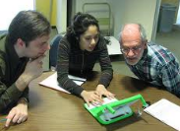

Total SLT reflects Credit value

Figure 1: Difference between TCL and SCL

MQA devised the Malaysian qualifications Framework (MQF), an instrument that develops and classifies qualifications based on a set of nationally and internationally approved criteria. MQF clarifies the earned academic levels, learning outcomes of study areas and credit system based on student academic load. MQF requires that all programmes must have outcomes. Programme Outcomes are statements on what students should know, understand and can do upon completion of a period of study. They are specific, understandable, measurable, assessable, student-cantered statements and those programme outcomes must be seen and verified through various forms of measurement.
“Student achievements are measured by learning outcomes. These learning outcomes distinguish the varying competencies as to what a student will be able to do at the end of a period of study” (Malaysian Qualifications Agency, 2010a). MQA has organised the learning outcomes into eight Learning :
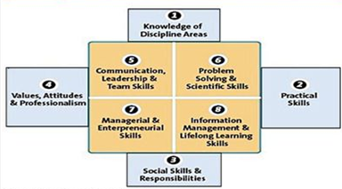
1. Knowledge of Discipline Areas
2. Practical Skills
3. Social Skills, Responsibility
4. Value, Attitudes & Professionalism
5. Communication, Leadership & Team Skills
6. Problem Solving & Scientific Skills
7. Mangerial & Entrepreneurial Skills
8. Information Management & LifeLong Learning Skills

Figure 2: Eight Learning Outcome Domains (Malaysian Qualifications Agency, 2010b)

Learning outcomes are linked to the credit system which gives value to all student learning time and are not based on the contact hours between lecturers and students” (MQA, 2008). If a course is worth 4 credits, the total hours of Student Learning Time is = 4 x 40 credits = 160. These 160 credits comprises of Lectures (42 hours), Tutorials (12 hours), Others (104 hours). For a topic, can comprise of a lecture (2 hours), Tutorial (1 hour), Pre-class reading (3 hours), Group Discussion (1 hour), Assignment (2 hours) for a total of 9 hours student learning time. The 160 hours must then be divided accordingly for all the topics, and the examination.

1.2 PROBLEM STATEMENT

For every credit that a course has, MQA has stipulated that the learning hours (or notional hours as is the term) must be 40 hours (MQA, 2010). Thus a 3-credit course requires each student to study 120 learning hours. The problem faced by the college was how to encourage SCM students to change from being passive and reluctant learners into willing learners who would study on their own for 40 to 44 hours a week, and not to rely on spoon-feeding by their lecturers. These learning hours must also be tested and evaluated. Students at SCM do not spend enough time in self-directed learning. As a result many do not achieve a CGPA of 2.0 and above. In the move to Student-Centred-Learning, a question on the minds of the SCM academic staff was how to get students to do their own learning outside of the college hours.
In order to answer this question, 29 Diploma In Corporate Administration programme students and 10 Diploma In Executive Secretaryship students were introduced to a Learning Management System (LMS) named Moodle. The purpose of the LMS was to provide a Virtual Learning Environment (VLE) for the students to learn, interact and receive feedback from the facilitator.

1.2.1 Use of a Logbook
Since 2010, SCM has instituted the practice of making it compulsory for all students to keep an active Logbook every semester. Previous studies have shown that the use of a logbook can support SDL among students and workers in the workplace (Pierce, Sale Mahoney, Hooker and May, 2009). All students at SCM are given a log book where they were expected to record their daily study activity. The facilitators at SCM are also required to check their students’ logbooks inside the classroom (during lectures or tutorials) Supervision and monitoring of the logbook is crucial for its implementation.
The Logbook method is an intentional guided learning that has been used to great success in creating a form of “learning contract” between students and employers (Pierce, Sale Mahoney, Hooker and May, 2009). In that case study, final year students at the Royal Veterinary College used a logbook designed by the PDSA staff. The purposes of the logbook were to (i) encourage students set their own learning objectives and to be more self-directed; (ii) allow the supervisor to structure training activities according to a records in the logbook; (iii) facilitate alignment of student-supervisor expectations. In that study, the logbook was critical to the students’ discipline in their learning process. In addition, the supervisors used the logbook to monitor the student’s progress and to adjust supervisor-student expectations. The study concluded that “Supervisor support of a logbook is crucial to its success in encouraging students to be more self-directed” (Pierce, Sale Mahoney, Hooker and May, 2009).
Many SCM students filled in their logbooks just before the facilitator inspected them. So between scheduled class time and before the dawn of the next day, there existed a vacuum of a mechanism to engage students in self-study. This study was to determine if the vacuum could be filled with introduction and adoption of a LMS that could engage students, and in so doing, influence their study habits for the better. One alternative hypothesis of the study, that was to be tested, was “the LMS will increase student self-directed learning hours”. Another alternative hypothesis was that “the more a student spends online in the LMS, learning the materials online, the higher will be the student’s quiz score”.

1.3 OBJECTIVES OF THE STUDY

The primary objective of this study was to determine if the implementation of a Moodle LMS among Diploma students at SCM, who were studying Information Technology, could increase self-directed learning hours among students. Two secondary objectives were also identified:
- to determine if the higher hours spent on the LMS, by a student, could translate into higher multiple-choice quiz scores.
- to determine the students’ perceived level of usefulness of the LMS in terms of getting students to fill in their logbooks regularly, with records of their daily self-study activities.
The end in mind was the formation of self-learners who would achieve higher scores in their tests and coursework. The LMS was designed to be easy to use, and to have reasonably fast load times (a maximum of 4 seconds for each Web page to load in a Web browser). It was also to contain relevant and engaging academic content to guide and expand a students’ study material. It was to also to enable the facilitator to regularly monitor and give feedback to the student.

1.4 SIGNIFICANCE OF THE STUDY

This study was conducted to determine if the use of a LMS, within the Melaka context, with the proper administration and choice of pedagogical activities could create self-directed-learners among Diploma-age students who were studying Information Technology subjects.
In addition, it was important to determine, again in the Melaka context, if more time spent online studying translated into better the grades of a quiz or test. Stamford College Malacca, or for that matter, the entire Stamford College group had never once used a LMS to influence students’ studying habits.
If the research successfully proved that the LMS and its interactions with the author and his students could make a difference, then:
- the LMS could be deployed across the centres. Meaning that there would be greater weight and impetus to get more academic staff onto the Moodle bandwagon as it were;
- more students could be encouraged to get onto Moodle as a means of helping them keep track of their activities. This would be helpful to enable them to keep daily records of their study activities in their logbooks;
- the use of the LMS could be a way for the slower learners to gain mastery of the particular topic, even though it took them longer;
- a community of LMS-savvy students could arise where the students would benefit from peer tutoring or peer assistance over the Internet, using the LMS as a communication vehicle.

  - DEFINITION OF KEY TERMS

Implementation is the installing, execution and maintenance of a live, Web-accessible system for end-users (the students). LMS means a Learning Management System, i.e., a system where students can access material, do activities and learn online.
Learning is defined as the acquisition of knowledge or skills through study, experience, or being taught (Online Oxford Dictionary, 2011); the change in behavior, creation or modification of cognitive structures, or construction of shared meaning (Vrasidas, 2000).
Self-Directed Learning is an learning posture and attitude that is translated into action and habits where the student is an active learner, The student is independently and actively engaging in learning beyond what the facilitator has given to the student. SDL is different from Lecturer-Induced-Learning (LIL). LIL is where the student does the minimum which are the directives given by the facilitator (Narayanasamy, 2010). For example a student takes an online quiz simply because the midnight deadline induces him or her to suddenly galvanise into action and to start studying the material and to click on the Quiz link. Beyond that, a student whose study habit is mainly the LIL-type, will not do anything else. He or she will neither bother to read beyond the syllabus, nor search YouTube for related videos on the topic at hand. A LIL-type student is knee-jerk-reactive type of student who only fulfils the basic minimum hours for the topic.
By Diploma students, is meant students who study five to six semesters of a programme after the SPM examination. The students who were interacted with the LMS whom the author had chosen for this research were Diploma In Corporate Administration students who were enrolled in three of the author’s courses: DCA202 Information Technology (6 students), DCA105 Desktop Publishing And Databases (23 students), and DES1203 Computer Applications In The Office (10 students).
Stamford College Malacca is the Melaka branch of Stamford College, a privately-owned Institute Of Higher Learning boutique college that offers a variety of business, English, secretarial, accounting and hospitality management Diploma programmes and one 2+1 U.K. Degree programme.

  - LIMITATIONS OF THE STUDY

1.6.1 Lack of server technical know-how
SCM did not have any prior knowledge of Server2008 Server-side installations, it was decided to not risk a “melt-down in our server” should something go awry with the Moodle installation. This meant the technical staff could not install Moodle in the local server. Therefore the next best solution was to have the LMS hosted externally. This was done (see next paragraph), however, much time had to invested by the author to ensure that the LMS was not only setup, but also maintained well. The learning curve was at least four months before the system could be labelled as “stable”.

    - Server-hosting financial constraint
In order for the LMS to exist, it had first to be hosted on a server. This made it necessary to source for a Web Hosting company. The project started off in October 2010 with some of the author’s own seed money to finance a shared hosting website. However, hosting a multi-user Moodle LMS on a shared server, even though it was Linux-based, was a poor idea due to the speed slowdowns that are inherent in all shared hosting plans. So without proper funding, the project looked like it might be “dead on arrival”. This threat to the project was so great that in the end it took a gift from the college to enable the LMS to be hosted on a Virtual Private Server for a generous sum of RM990 a year.

1.6.3 Size of student population
Another limitation of the study was the relatively small number of students studying Information Technology courses at SCM for the period of October 2010 to January 2011. The number of students was 24 from the Diploma In Corporate Administration programme and 13 others from the Executive Secretaryship programme. Thus the population size of the author’s students was small.

    - Inexperience with Student-Centred-Learning
Since May 2010, SCM has adopted a new paradigm shift that emphasises the definition, mechanics and achievement of student Learning Outcomes (LO). Based on the MQA model of LOs, the lecturer is now regarded more of a facilitator than a deliverer of content in a “one-size-fits-all” lecture. The facilitator at SCM now has the responsibility of embodying the curriculum with the Eight Domains of LOs (see page 3). To design a curriculum or a course that embodied this fully was easier to put on paper than to actually deliver it in the classroom.
The author was not familiar with Student-Centred-Learning methods as most of his teaching career was spent “spoon-feeding” the students with voluminous notes, PowerPoint slides and boring “one-size-fits-all” lectures. He had to pick up the skill by himself through surfing the Net, by reading journals – and finally by just doing it.

CHAPTER 2 - REVIEW OF LITERATURE

2.1 Theory and previous Studies

2.1.1 Foundations of Education
To gain a perspective on the foundations of education the table below lists seven education pioneers from whom learning theories originated.

Table 1: Education Pioneers and their Learning Theories
 | Educational Pioneer | Learning Theory
1. | Jan Komensky  (1592–1670) | Humane view of the child. An educational method, based on the children’s natural growth and development.
2. | John Locke  (1632 -1704) | One acquires knowledge from the information about the world that one’s senses. Uses the inductive or scientific method of learning
3. | Johann Pestalozzi (1746–1827) | Education is a social activity and the school as a social agency that helps to shape human character and behaviour.
4. | Jean Piaget  (1896–1980) | Human intelligence develops in sequential stages. The concept of readiness and appropriate learning experiences for each developmental stage. Based on developmental psychology.
5. | Albert Bandura  (1925-) | A social cognitive theory that states that “human functioning is explained in terms of a model of triadic reciprocality in which behavior, cognitive and other personal factors, and  environmental events all operate as interacting determinants  of each other” Bandura’s (1986:18).
6. | Lev Vygotsky  (1896-1034) | A framework that states that social interaction plays a fundamental role in the development of cognition. "Every function in the child's cultural development appears twice: first, on the social level, and later, on the individual level … higher functions originate as actual relationships between individuals." Vygotsky (1978)

According to McGhie (2009), all six of these theories reveal a common factor: learning is socially constructed. This emphasis here is that learning does not take place in a vacuum. On the contrary, successful learning is the result of the influence of many role players and factors.

2.1.2 Teacher-Centred-Learning (TCL)

Traditional teaching and learning has is its emphasis on teacher-centred, rote-learning and memorisation. In the Malaysian context there is a high proportion of rote learning among the on-campus learners which may be attributed to the exam-oriented teacher-centred approaches used in schools (Thang, S. M. & Azarina A., 2007). In Malaysia, Thang (2001, 2003, & 2005) revealed that the Malaysian undergraduates (both distance learners and on-campus learners) of the National University of Malaysia, seemed to prefer a teacher-centred approach to learning.
Another study conducted on Malaysian undergraduates indicated that a majority of the students from three major Malaysian public universities preferred the teacher-centred approach to learning (Thang, S. M. & Azarina A., 2007). The surface approach to learning, focuses more on rote memorisation of facts for the purpose of passing examinations, rather than meaningful understanding with a view to becoming effective practitioners (Blumberg, 2005). One solution to this problem is to inculcate SDL among students.

2.1.3 Approaches to learning
Qualitatively different approaches to learning (surface and deep) were identified in the mid-1970s (Marton et al., 1997). All deep approaches, have at their core, an intention by the student to understand ideas and seek meanings. (Prosser & Trigwell, 1999).
There are a number of terms that are the same as self-directed-learning – active learning, self-managed-learning, learning-centred. Kowles (1984) believed in andragogy, which states that students are adults, not children, and that they have their own ways of learning, and are able to connect their experiences with the learning process. Deep learning is about the student taking responsibility. This is opposed to shallow, or lazy learning, where the student takes “spoon-fed” knowledge, takes much notes without much reflection or thinking, and regurgitates them during an exam. Deep learning happens when a student thinks actively about what they have learnt, and purposefully seek knowledge, and then reflects, questions and challenges that knowledge, and integrates it into his or her own context (Phillips, 2005).
Allan (2003) contended that for active learning to take place, learners must develop independence in learning, be aware of their strengths and weaknesses, know their own learning processes, and use knowledge flexibly and creatively.
The main study on approaches was conducted in 1983 by Entwistle and Ramsden (1983). They coined a list of attributes as “Approaches to Studying Inventory (ASI)”. A revised version was released by Entwistle and Tait (1994) with the “Revised Approaches to Studying Inventory (RASI)”. Thang (2004) summarised the two inventories as the “New Approaches To Studying Inventory (NASI)”. See overleaf for the NASI table.

Table 2. New Approaches To Study Inventory

Approach | Meaning
1. Deep approach
Looking for meaning | Learners look for meaning in studying.
Active interest/critical stance | Learners have an active interest. They interact actively with what is being learnt and relate to real life.
Relating and organizing ideas | Learners relate new information to previous information actively and organize ideas mentally.
Use evidence and logic | Learners use evidence and logic in trying to understand materials and to arrive at conclusions.
2. Surface approach
Relying on memorizing | Learners rely on rote learning.
Difficulty in making sense | Learners find difficulty in understanding and making sense of what is being read.
Unrelatedness | Learners find difficulty in perceiving what is important and also in seeing an overall picture.
Concern about coping | Learners are unduly concerned about coping with work.
3. Strategic approach
Determination to excel | Learners are competitive and self-confident and determined to achieve success.
Effort in studying | Learners put in extra effort to make sure that work is being done well. They concentrate well on work.
Organized studying | Learners have organized study methods. They ensure that appropriate conditions and materials are available.
Time management | Learners are able to organize time effectively.
4. Lack of direction | Learners are cynical about higher education.
5. Academic self-confidence | Feel driven to enter university to please others.  Learners feel confident about ability to cope with work. No difficulty in understanding new ideas.
6. Extrinsic motivation | Learners are primarily motivated by the qualifications and the prospects of a good job on graduation.
7. Syllabus-boundedness | Learners have the intention to restrict learning to the defined syllabus and tasks requirements.
2.1.4 Self-Directed Learning (SDL)

The term Self-Directed Learning was first publicised by Knowles (1975). It is an approach that encourages students to become independent learners. With SDL in place and thriving, colleges can concentrate on learning hours instead of teaching hours – hence less contact hours between student and lecturer may result. This reduction in lectures creates more opportunities for personal study, and curriculum that places emphasis on the development of professional skills (such as teamwork and effective communication) as opposed to merely the development of the cognitive realm.

Roger’s 1969 study comprehensively defined the term "Self-Directed Learning" as: a quality of personal involvement — the whole person in both his feeling and cognitive aspects being in the learning event. It is self-initiated. Even when the impetus or stimulus comes from the outside, the sense of discovery, of reaching out, of grasping and comprehending, comes from within. It is pervasive. It makes a difference in the behavior, the attitudes, perhaps even the personality of the learner. It is evaluated by the learner. He knows whether it is meeting his need, whether it leads toward what he wants to know, whether it illuminates the dark area of ignorance he is experiencing. The locus of evaluation, we might say, resides definitely in the learner. Its essence is meaning. When such learning takes place, the element of meaning to the learner is built into the whole experience.

The self-directed learner is one who has internalised the norms of the community (for example the course participants) — he has a sense of self-direction, and of meaning an purpose in his own life and in his relationship to SCM. He values that relationship and sees the faculty as the legitimate source of influence over his attitudes and behavior (Rubin, Sweetwood, 1971).

What are the traits of a self-directed learner? Tough (1971) suggests these traits as being evident among certain individuals:
1. Efficiency
2. Confidence in individual ability
3. Freedom to pursue learning at own pace
4. Reliance on self as a resource
5. Ability to find resources
6. Insight into personal learning abilities
7. Self-reliance and independence
8. Proud of individual accomplishment (pp. 92-93).

Guglielmino (1977) developed a self-directed learning readiness scale. She isolated eight critical factors in self-directed learning.
1. Openness to learning opportunities
2. Self-concept as an effective learner
3. Initiative and independence in learning
4. Informed acceptance of responsibility for one's own learning.
5. Love of learning
6. Creativity
7. Future orientation
8. Ability to use basic study skills and problem solving.

2.1.5 The benefits of SDL

In his keynote speech at TED, Salman Khan explained the benefits of his Online Academy where more than a million students had enrolled online (Khan, 2011). The students viewed his narrated and animated videos on various topics ranging from mathematics to business topics. The videos themselves were clear and entertaining, making understanding and learning a joy. What used to be homework was now being completed in school by the student. The beauty of the video instructions was that the students could learn at their own pace. The videos could be replayed as often as possible.
Salman espoused a method of learning based on the “learn math the way you'd learn anything, like the way you would learn a bicycle. Stay on that bicycle. Fall off that bicycle. Do it as long as necessary until you have mastery” method (Khan, 2011). This method ensured that the student would only move on to a higher level topic once he or she had completed a self-assessment quiz where the requirement was to complete ten consecutive correct answers.
The teachers, whose students enrolled in Salman Khan’s Academy, found that because the students had studied on their own online, the class contact time became more student-centred. In addition, more quality time was now being spent assisting and counselling the student. In addition, through his innovative LMS, teachers could better monitor students, even to the extent of getting the better performing students to peer-tutor the slower ones. The net result was that every student progressed upwards towards mastery of topics, albeit at his or her own pace (Banerjee, 2011).

SDL does not absolve the facilitator or teacher or tutor from his or her responsibilities to ensure that learning takes place in the student. SDL does not make the teacher role redundant. Students need clear learning objectives and good, timely feedback from tutors in tutorials and directed learning sessions (Dale et al., 2008).

2.1.6 The relationship between teaching and SDL

There are two main role players in learning: the student and the teacher (facilitator / tutor / lecturer). All role players at higher education institutions must bring their part in order to achieve success in learning. McGhie (2009) views the learning process as a “partnership between the student as the learner, and the lecturer as mediator and facilitator of the learning process”. It is of extreme importance that lecturers know and understand their role(s) in the learning process in order to be facilitators to successful learning for their students. In simple terms, learning is the ‘shared responsibility’ between the students and the lecturer.
Donald, Lazarus and Lolwana (1997) argued that for successful learning to take place, a lecturer should have multidimensional roles that are inter-twined. They viewed a lecturer as needing to be someone who fulfils one of the roles in the table below.

Table 3: The Multidimensional Roles of a Lecturer

 | Role | Description of Role
1. | An educator | The lecturer is responsible to promote the best possible learning by using various strategies to help the students to reach their potential.
2. | A researcher | The lecturer mediates and stimulates thinking. He or she shows students how to think by the research means of question, observe, evaluate and re-question.
3. | A leader | The lecturer is responsible to give direction and guidance in the classroom. He uses professional insight, maturity, and influence to provide purpose and direction to the and learning situation.
4. | A manager | To manage the classroom effectively and create an organised and orderly structure. He provides a environment that is conducive for students to learn freely.
5. | A motivator and supporter | The lecturer ensures a healthy and safe classroom environment. He identify, intervenes and address problems. He counsels and encourages students with special needs.
Note: table adapted from McGhie (2009).

Adams (1996) identified seven key issues that need to be addressed in the learning process. These key issues are: the context of learning; teaching methods / styles of educators; the differences among learners (self-esteem, self-direction, self-control); compensatory education (proficiency in learning); coping skills; family support; and composition of teaching staff.

2.1.7 Bloom’s Taxonomy

Each student is an individual with his or her one style of learning. In 1956, Benjamin Bloom lead a committee of colleges, and identified three domains of educational activities (Bloom, 1956):
- Cognitive: mental skills (Knowledge area)
- Affective: growth in feelings or emotional areas (Attitude area)
- Psychomotor: manual or physical skills (Skills area)

The output of the committee was the design of taxonomy (the practice and science of classification) named Bloom’s Taxonomy. The cognitive segment of the taxonomy has since been revised by Anderson (2001) and Forehand (2005) to become the modern version of Bloom’s cognitive taxonomy. It is most useful as classification of learning objectives that educators can set for students. For example, in the setting of quizzes, test and examinations, early questions can be set to test the poorer students’ level of remembering, whilst later questions can test students on their analytic skills.

Table 4: Modern Bloom’s Taxonomy

Cognitive level | Skills | Behaviors that you can test online | Behaviors that you cannot test online
Remembering | Recall or remember information | List, label | Recall, define, repeat
Understanding | Explain ideas or concepts | Identify, select, locate | Classify, describe, explain
Applying | Use methods, concepts in new situations  Solve problems using required skills or knowledge | Choose, interpret, solve, operate (computer itself or simulation of something else), write (short answer) | Demonstrate, illustrate, use, write examine, modify experiment
Analyzing | Recognize patterns  Distinguish and organize parts | Compare, differentiate, distinguish | Contrast, criticize, examine, experiment, question, test
Evaluating | Justify an opinion or decision | Select | Appraise, argue, defend, evaluate
Creating | Create a new product or point of view | Write (short answer) | Construct, create, design, formulate
Source of table: Dickinson, M. (2010)

2.1.8 Gardner's Theory of Multiple Intelligences
Gardner (1983) advocated a theory that accounts for a broader range of human potential in children and adults. It suggests that individuals learn in a variety of ways. It also suggests there are a variety of possibilities to facilitate learning:
Table 5: Gardner’s Theory of Multiple Intelligences
# | Intelligence type | Capability and perception
1. | Linguistic | words and language
2. | Logical-Mathematical | logic and numbers
3. | Musical | music, sound, rhythm
4. | Bodily-Kinesthetic | body movement control
5. | Spatial-Visual | images and space
6. | Interpersonal | other people's feelings
7. | Intrapersonal | self-awareness
Technology can be integrated into our classrooms to focus on learning theory and educational practices. However technology is not a “one-size-fits-all” panacea because students have different intelligences. Technology should be used by considering how people learn best. Technology in the classroom can be a potent tool if a lecturer is mindful of the different learning strengths and needs of his or her students, as indicated by Gardner’s popular theory (Jackson, Gaudet, McDaniel, & Brammer 2009).

2.1.9 Blended Learning
Blended is the combination of multiple approaches to learning. It can be accomplished through the use of ‘blended’ virtual and physical resources. A typical example: a combination of technology-based materials, face-to-face sessions used together to deliver instruction and an autonomous learning. Valiathan (2002) describes the term blended learning as “a solution that combines several different delivery methods, such as collaboration software, Web-based courses and knowledge management practices. Blended learning also is used to describe learning that mixes various event-based activities, including face-to-face classrooms, live e-learning, and self-paced learning”.
The focus of teaching is on content and the quality of presentation. However, there have always been other kinds of teachers who have included transmission methods in their approach, but the focus of their intention in teaching is on the students, with the aim of changing students’ views or conceptions of the phenomena they are studying. These teachers’ approach to teaching could be described as student-centred. Teachers who adopt the student-centred approach to teaching further emphasise teacher-student interaction, teachers’ important role in facilitating understanding and the importance of students constructing their own knowledge. (e.g., Kember, 1997; Prosser & Trigwell, 1997; Vermunt & Verloop, 1999).
Research has shown that teachers’ approaches to teaching are related to their conceptions of teaching (e.g., Prosser & Trigwell, 1999). Teachers whose approach to teaching is student-centred in nature see teaching as facilitating student learning or students’ knowledge-construction process or as supporting students’ conceptual change. On the other hand, teachers whose approach to teaching is teacher-centred see teaching more as transmission of knowledge (Prosser & Trigwell, 1999). However, researchers have different views of the stability of the approaches to teaching. According to Kember and Kwan (2002) approaches to teaching are relatively stable, but Prosser and Trigwell (1999) emphasise the contextual and dynamic nature of approaches to teaching.
Recent research has further shown that teaching and learning in higher education are not independent of each other but continuously interact. Research shows that university teachers’ approaches to teaching are associated with their students’ approaches to learning, and, furthermore, that teachers’ approaches to teaching are connected with the quality of students’ learning outcomes (e.g., Trigwell, Prosser & Waterhouse, 1999; Trigwell, Prosser and Waterhouse, 1999).
A study by (Dale, Head, & May, 2008) revealed that to introduce self-directed Learning to an organisation was not straightforward. There was a need "for structure and clarity in terms of rationale and objectives, and the role of staff development".
There is also a need for supporting lecturers to do that role change from teacher-centred-learning to student-centred-learning. In her study of student and staff perceptions of a new medical curriculum, McLean (2003) highlighted the importance of staff development and training to help the staff to be better facilitators. She also documented that need for both the student and facilitator to be clear on each other’s roles, lest there any false assumptions. In another study, McLean and Van Wyk (2006) advocated “the need for facilitators to be trained in the principles of self-directed learning”. Feedback is critical to the process of learning, as it is argued that this promotes improvement and achievement of goals more effectively than assessments (Steinert & Mann, 2006). According to Maudsley (1999), facilitators need to realise that they have not become redundant if self-directed learning were to be introduced to students. Facilitators are to assume a new role of spending more time explaining, counselling and monitoring the student instead.
2.1.10 Constructivism
Constructivism is a learning theory that emphasizes collaborative learning, such as projects involving in students and teachers. Its goal is to create learning communities as strongly reflected in social constructivist ideas (Vrasidas, 2000). Constructivism is when people actively construct new knowledge as they interact with their environments. Everything they read, see, hear, feel, and touch is tested against their prior knowledge and if it is viable within their mental world, it may form new knowledge they carry with them. Constructivism asserts that learning is particularly effective when constructing something for others to experience.
Constructivism includes these instructional activities: Modelling, coaching and scaffolding. Modelling is demonstrating to the learner how (and why) to perform the necessary activities needed to complete a task. Coaching is intervening at critical junctures with instruction, encouragement and feedback. Scaffolding is giving help, adjusting to the learner’s current level. Once the student has mastered the topic, all help (scaffolding) can be removed (Brandon, 2004).
An example of Constructivism, is when a student tries to explain ideas to someone else in their own words, or produce a website or blog that explained these concepts, will have a better understanding than a student who just read a book and then forgot what he or she read the next day. This kind of interaction is one of the most important components of any learning experience (Dewey, 1938; Vygotsky, 1978; Simpson & Galbo, 1986). Moore (1989) identified three types of interaction in distance education: learner-teacher, learner-content, and learner-learner. See the table below:

Table 6: Moore’s Three Types Of Interaction In Distance Education
 | Interaction type | Learning occurs when …
1. | Learner-Content | … learners interact with some content. Content is found in books, abstract ideas, and websites, among others.
2. | Learner-Teacher | … a lecturer delivers instruction in the form of a lecture, feedback, encouragement. The learner interacts by asking questions, submitting homework and discusses problems.
3. | Learner-Learner | … learners collaborate with peers on projects, assignments, discussions, exchange ideas, and interact on topics that relate to the course.
Source: (Vrasidas 2000)

2.1.11 Social constructivism
Social constructivism extends the concept of constructivism into social settings. Groups construct knowledge for one another, collaboratively creating a small culture of shared artefacts with shared meanings. Activities and artifacts produced within the group as a whole will help shape how each person behaves within that group. Constructivists believe that effective learning happens when learners are active participants in, and architects of, their own learning environment.

2.1.12 Instructivist Design
The Instructivist approach is where the teacher is in charge of curriculum design, and instructional planning. It is a “Sage on the Stage” approach, where the teacher controls the teaching method and content. Communication is mainly one-way from the teacher to the students The teacher acts as a “channel”, delivering “objective, correct” knowledge to the students. (Bjørke, S.A 2003).
Having understood these learning and teaching theories we now turn our attention to implementing a LMS that can used as a platform for some, if all, of the above mentioned theories.
2.2 Hypotheses of this Research Project

According to the previously mentioned literature review and purpose of this study, this study establishes the following hypotheses and examines correlations among personality traits, self-directed learning and demography:
H₁：The amount of time spent on the Moodle-based LMS has a significant positive influence toward the increase of self-study hours.
H₂：The amount of time spent online on the LMS has a significant positive influence toward higher scores in a multiple-choice-question quiz.
H₃：Use of the LMS has a significant positive influence toward the students’ perceived overall interest in the course.

2.3 THEORETICAL FRAMEWORK

According to the previously mentioned hypotheses, this study builds the following framework in order to understand the relationships among: time spent on the LMS, increased hours of self-directed learning, and higher quiz scores as in Chart 1:
Overall Usefulness
Ease of use

Access speed factor

Easier logbook recording

Interest factor
Self-directed Learning

Increase in self-study hours

Study of topics beyond syllabus

Usage of LMS

Time spent
Quiz

Higher scores

Desire of higher scores

Figure 4:
TheoreticalFramework
2.2.1 Constructivism
2.4 Learning Management Systems (LMSs)

A Learning Management System is a Web application that is run on a server located anywhere in the world and accessed by a Web browser. It gives educators a tool to create a course website and provide access control so only enrolled students can view it. LMSs are designed to enhanced learning capabilities within educational institutions (universities, schools, training providers etc.). Open Source LMS solutions are an attractive option for organizations that are cost conscious. In the next section, I shall briefly examine three leading Open Source LMSs.

2.4.1 Introduction to Moodle
Moodle (abbreviation for Modular Object-Oriented Dynamic Learning Environment) is a free source e-learning software platform, also known as a Course Management System (CMS), Learning Management System (LMS), or Virtual Learning Environment (VLE). As of May 2011 it had a user base of 54,354 registered and verified sites in 212 countries, serving 43 million users in 4.4 million courses.
The name Moodle is “an acronym for Modular Object-Oriented Dynamic Learning Environment, … a verb that describes the process of lazily meandering through something, doing things as it occurs to you to do them, an enjoyable tinkering that often leads to insight and creativity. As such it applies both to the way Moodle was developed, and to the way a student or teacher might approach studying or teaching an online course” (moodle.org, 2011).
Moodle is a software package for producing internet-based courses and web sites. It is an ongoing development project designed to support a social constructionist framework of education. Moodle is provided freely as Open Source software (under the GNU Public License). Basically this means Moodle is copyrighted, but that you have additional freedoms. You are allowed to copy, use and modify Moodle provided that you agree: to provide the source to others; to not modify or remove the original license, and apply this same license to any derivative work. Moodle is designed to scale from a single-teacher site to an 50,000-student University or enterprise site.

Strengths

- Highly flexible “Swiss-Pen-Knife” modular system that allows administrators to pick and chose the installation of over 500 blocks, modules and filters from http://moodle.org/mod/data/view.php?id=6009
- Based on Constructivist pedagogy - a huge number of activities to choose from.
- Large community of world-wide users and developers
- A matured product with over 8 years of development duration (since 2003)
- Large number of attractive and customisable user themes
Weaknesses
- Difficult to upgrade from Moodle 1.9.x to Moodle 2.x, with all original modules intact, unless special care is taken – this is the major cause of concern among educators and teachers who are not as versatile or skilled in server-side technology
- Too many mouse-clicks (“clunky”) to do basic tasks compared to other LMSs
- Not enough Web 2.0 features – even with Moodle 2.0. The number of “Drag and Drop” features is small compared to “Click-Mouse-and-Choose” features
- Moodle 2.0 file repository/upload system is difficult to use – Moodle has to resort to legacy files in order to restore some resemblance to the older, but easier to use course file system under Moodle 1.9.x.
2.8.2 Claroline
Claroline was the brainchild of University of Louvain in Belgium. It has been in development since 2004. Claroline is organized around the concept of "spaces" related to a course or a pedagogical activity. Each space provides a list of tools that enable creation of learning contents, management of training activities, and interaction with other students. Claroline developed as an open-source alternative to Blackboard.
Strengths
- Claroline is very easy to use. It is very intuitive interface.
- Allows educators to create Learning Paths (sequence of learning objects).
- No Scroll of Death as the topics are well-laid-out with a left-menu system.
- Collaboration is encouraged through announcements, and message boards.
- It has very good documentation and it is easy to refer to information.
- Enables educators to setup a course up and-running very fast.
Weaknesses
- weak in tracking student competencies.
- Lack of comprehensive pedagogical tools as compared to Moodle.
- The two user levels – student and instructor. An instructor can assign a student as a tutor but this not include additional administrative rights – just the right to belong to several groups simultaneously.
- The assignment submission module has no shopping cart.
- Lacks business rules, where pre-registration, waitlists, reminders, and so on are matured.
- Announcements are manually driven. (Claroline, 2011)
2.8.3 Canvas

Canvas is the “new kid on the block”. It was released in June 2010 into the crowded LMS market. As of April 2011, up to 30 institutions have switched from Blackboard to Canvas (Lal, K., 2011). Below are the author’s comments based on with his own Canvas account.
Strengths
- Built-in gradebook that saves lecturers time when grading assignments
- Strong drag-and-drop features with “Facebook-like” Web 2.0 interface
- Rubric next to a student assignment for easy marking – a major time-saver
- Allows students to be informed of events in a variety of ways (SMS, email, etc.)
- Built-in chat is nicely integrated with built-in audio/video recording
- Fewer mouse-clicks to create course content compared to Moodle
- Powerful calendar and real-time reporting
Weaknesses
- No user-created profile icons
- No user-customisable themes (lack of GUI eye-candy compared to Moodle)
- No Countdown feature for test events to put on the calendar
- Needs to allow import of quiz questions from a XML file
- No Open Source mods and activities that the user can add and drop (ala-Moodle)
- Needs to include a Moodle course converter to crush the competition
- No SCORM capability
- Smaller world-wide community of users and developers
- Less matured LMS due to its relative newness to the LMS scene.
(Canvas, 2011; Lal, K., 2011, Canvas Support Centre, 2011)

2.5 Rationale for choosing for Moodle

Moodle was chosen as LMS for Stamford College Malacca for these reasons:
- The author already had at least 2 years of experience using Moodle version 1.9.8 with the free Moodle hosting site www.keytoschool.com;
- The author had online courses in the www.keytoschool.com service where the course content had been created. To choose Claroline would mean hundreds of pain-staking hours spent building the Moodle course pages would have gone down the drain. Instead the existing courses from www.keytoschool.com could be easily backed-up and restored on the new Moodle server;
- Moodle was the only Learning Management System that was available from the CPanel options of LMSs that the Web Hosting company had. This enabled the author to create the LMS easily;
- The author had access to a rich variety of activities, blocks and filters at his disposal, thanks for http://moodle.org;
- Moodle’s online community would be a major source of help and assistance in times of need if or when the system were to have problems.

2.5.1 Moodle – a Constructionist pedagogy-based LMS

Moodle was created around the Constructionist theory. Martin Dougiamas’ thesis paper in 1999 was the seeds of the project for what would become the most widely used Open Source LMS (Dougiamas, 1999). Moodle supports the belief that 'knowledge' is not seen as an object that can be passed from one person to another. Rather, understanding and meaning are constructed through the interactions of learner with one another. Knowledge is constructed through a dialogue process as learners actively engaging each other in learning tasks. Moodle LMS’ strength is it emphasises learning activities instead of merely objective content.
Constructivist allows the learner to create, adjust, modify and manipulate until understanding is fully established on a given task. Learning could be supported by the tutor who gives the learner online reflection diaries, video tutorials, quizzes, wikis and mind maps to build in Moodle (Bjorke, S.A, 2003). Moodle allows not only transfer of knowledge from the instructor to a group of learners, but facilitates the learner to build upon his or her base knowledge within a domain.

2.5.2 Moodle and Bloom’s Taxonomy
Moodle has activities that fit the entire gamut of Blooms’s Digital Taxonomy:
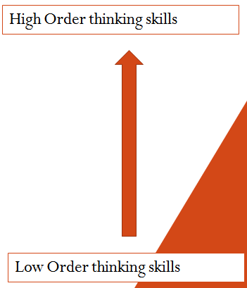
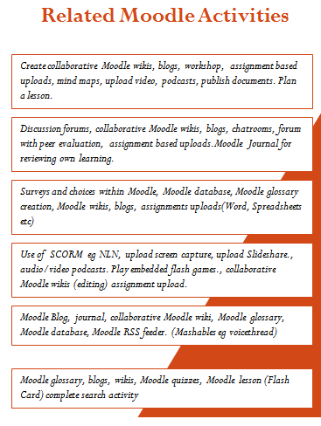
(Rollins,
2011)
Creating
Evaluating
Analyzing
Applying
Understanding
Remembering
Figure 4: Moodle’s Bloom’s Taxonomy related activities

2.5.3 Implementation of Moodle LMS by others

In this section, we will look at other implementations of Moodle in various organisations to get a feel for the rationale behind the motives.
Research was conducted by (Kamarulzaman, Madun & Ghani, 2010) to study University Malaya students’ attitude and motivation towards eLearning and Moodle in the learning process. The study concluded that Moodle was useful tool, easy to use and friendly for University Malaya students at all levels.
In 2006, The Open University (OU) chose Moodle in for their needs: 100,000 students, 10% of students with a registered disability and a high number of part-time students who were inmates in prison. OU decided for Moodle of if was flexible and allowed programmers and academic staff to “substantially enhance and extend for their needs (accessibility, size, permissions, etc)” (Sclater, 2006).
Lόpez (2006) let students work with virtual diaries and let students hand in homework or projects via Moodle, this virtual diary has proved to be an important tool. To do action research is to plan, act and observe and reflect more carefully, more systematically and more rigorously than one usually chooses in everyday life.
In 2007, Athabasca University (Canada) selected Moodle over WebCt and LotusNotes. Moodle took eleven first place ratings The first place preferences within individual criteria show the following: WebCT 6; LotusNotes 7; and Moodle 58. (Briton, Gismondi, Heller, Kennepohl, McGreal, & Nelson, 2007).
Boehning (2008) did a qualitative case study to understand the experience of one eighth grade Language Arts class who used Moodle, with regards to multiple intelligences and learning styles. Significant themes such as fun, participation, helpful, logistics, learning, and Myspace were identified and described from the students' and teacher's point of view. The result of the study was that students perceived Moodle to enhance the learning process.
In 2008, University Of Canterbury chose Moodle as its LMS based on positive feedback from lecturers and students. To adopt the existing Blackboard (with licensing fees and no guarantees of no fluctuations in USD currency rates) in favour of the Open Source Moodle LMS (UOC, 2008).
A study on online Moodle elective courses at Croatian medical schools concluded that “elective e-courses may be a successful model of how faculty and students at higher education institutions can collaborate and integrate e-learning into their current curricula” (Đogas, Dabić, Drenjančević, Kukolja, 2008). In that study, the majority of students expressed their satisfaction due to these factors: more contact time and communication with peers and tutors, self-assessment opportunities, flexible learning environment, faster and easier information retrieval.
A Moodle intervention program in University of Oviedo (Spain) was used to train studying and self-regulation strategies in university students. The programme promoted a series of strategies that allowed students to manage their "learning processes in a more proficient and autonomous way ... data suggest that the students enrolled in the training program, comparing with students in the control group, showed a significant improvement in their declarative knowledge, general and on text use of learning strategies, increased their deep approach to learning, decreased their use of a surface approach and, in what concerns to academic achievement, statistically significant differences have been found in favour of the experimental group" (Núñez & Cerezo & Bernardo & Rosário & Valle & Fernández & Suárez, 2010).
In November 2010, OU announced that they would continue with Moodle 2.0 as their VLE of choice. OU intends to upgrade its existing Moodle 1.9 to 2.0 over a period of 12 months (Ross, 2010). In the same year, Monash University's (Australia) identified Moodle 2.0 as best aligning with the University’s strategic educational objectives. Monash’s primary requirements were “educational strengths and priorities, usability, accessibility, interoperability with other key systems, flexibility, performance, disaster recovery, security and privacy” (Monash University, 2010). Sacred Hearts Girls College (New Zealand) chose Moodle as the college’s LMS on the basis of investigations carried out to choose the best LMS. The two main reasons were: Moodle’s long history of development (since 1999) and its world wide community of users and free support (SHGC, 2010)
In November 2010, after undertaking a thorough assessment of the competition in the LMS industry, Open University (UK) choose Moodle 2.0 as their LMS of the future. This due to OU’s experience with modding and customising Moodle 1.9 for their own needs, including development of several key modules (forum, blog, wiki and quiz engine), integration Google Apps for Education, personalised facilities, and enhanced user generated content.
Many of the advantages of the openness of Moodle providing adaptability, flexibility and ability to meet the needs of the University can only be realised with a commitment to development capability in the University.
Upon completion of the assessment the working group determined that Moodle best aligned with the University's strategic educational objectives. Moodle stacked right up against the other leading Learning Management Systems in terms of functionality and will come with the added bonus of increased control of features and lower cost.
CHAPTER 3 – METHODOLOGY

3.1 Research Design

3.1.1 Creation of the Moodle LMS
As the entire research was based on a LMS, the first critical step was to create the Moodle LMS. The purpose of the LMS was to house the online content of the Information Technology courses (DCA202 Information Technology and DCA105 Desktop Publishing and Databases) for the Diploma In Corporate Administration; and courses (DES1203 Computer Applications In The Office) for Diploma In Executive Secretaryship students to access in-class and from home. Refer to Figure 4.
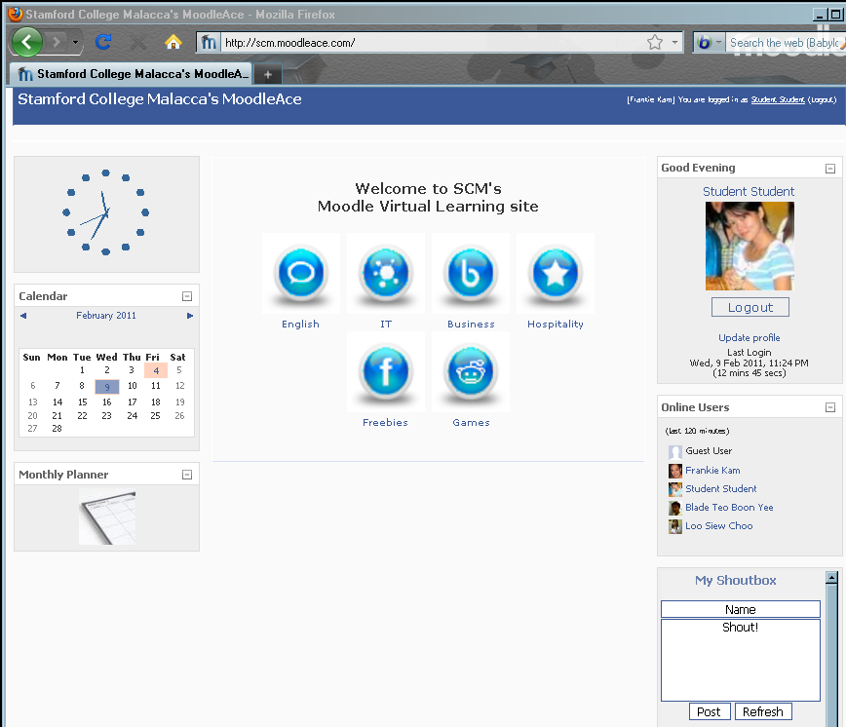
Main course menu
Login screen
User login list
Shout
box
Monthly Planner
Calendar
System Clock
Figure 5: Screenshot shows the original LMS homepage of the LMS
The foodle theme (mimicking the Facebook look) was initially used.
3.1.2 Key factors involved in the creation of the LMS
There was an urgent need to get the LMS working before the semester began in November 2010. Hence there very narrow window of time as the LMS was setup in October 2010. The creation and implementation of the LMS was dependent on these crucial factors, sorted according to importance.
- Factor 1: Web Hosting
- Factor 2: Access speed issues
- Factor 3: Activities, modules and blocks
- Factor 4: Graphical User Interface
- Factor 5: User engagement
- Factor 6: Online course content
- Factor 7: Monitoring methods

3.1.2.1 Factor 1: Web Hosting
A web host is a server that stores the website or LMS. A major constraint in the choice of web hosting was the finances needed to support the LMS. This was due to the fact that there are three main types of Web hosting, each with a different “price tag”.
Firstly, shared hosting is a website that shares a server with hundreds of other sites. This is the most basic Web hosting, where site files are stored on a server that shares disk space and other resources on the server. The initial website http://scm.Moodleace.com was a shared hosting setup. Linux distro Centos 5 was the preferred platform. The specifications were 10Gb hard disk quota, 50Gb monthly bandwidth at RM80 per annum. This choice however, proved to be too slow due to the fact that LMS shared the Web Host company’s server resources with a few hundred other websites. Students complained that the system was slow and during computer lab sessions, entire screens were blank. This defeated the whole purpose of the system.
Secondly, a virtual private server (VPS, also referred to as Virtual Dedicated Server or VDS) is a method of partitioning a physical server computer into multiple servers such that each has the appearance and capabilities of running on its own dedicated machine. Each virtual server can run its own full-fledged operating system, and each server can be independently rebooted. This server gives the features of a dedicated server on a machine that is shared by other websites. This option gave the LMS its own virtual space, complete with Root access, without the high costs of a dedicated server. Within a month, a desperate decision was made to upgrade the subscription to a Linux Centos 5 VPS. This meant that the author was given root access, increase in speed (250Mhz Processor, 20% increase CPU clock speed) and resources (512Mb RAM, 250 Gigabytes per month monthly transfer bandwidth, 20 Gigabytes hard disk space, Plesk 9.0 Control Panel).
Mr K. Narayanasamy, SCM’s Principal generously agreed to sponsor the VPS rental expenses which amounted to RM1,182 per annum (i.e., RM990 per annum for the VPS and RM18 x 12 months for Plesk). This decision was to play a crucial role in ensuring smooth access of the LMS, especially during computer laboratory classes. In November 2010, the domain name www.Moodleace.com was created and hosted at the sub domain http://scm.Moodleace.com. The Hosting company chosen was SKSA Technology (S)
Thirdly, a Managed Dedicated Server is a set up was neither within the author’s financial means nor was it practical, given the current number of students who were enrolled in the LMS course. Even though it came with more hard disk space and a greater upload and download pipeline, the main consideration was the cost itself which was RM290 per month. The managed dedicated server was considered as an unnecessary luxury which was beyond the means of the sponsor of the project (i.e., SCM).

3.1.2.2 Factor 2: Access speed issues

It is widely accepted that fast-loading pages improve user experience. Research (Young, Smith 2006) has shown that about a third of sampled broadband users are reluctant to wait more than 4 seconds for a web page to load.
The fast response times of the LMS was the main deciding factor in the physical setup of the LMS. This was due to the number of students in the IT classes. As the lectures and tutorials were held mainly inside the computer lab, the system had to support anywhere from five to twenty students concurrent students. In order to allow for a fast response time from the system, over a period of three months, the following steps were implemented by me (many late nights and little sleep ensued to ensure that the LMS was upgraded without any side-effects to the course contents):

The trick of caching of PHP compiled code via eAccelerator software was use to speed up access. PHP Hypertext Preprocessor (the name is a recursive acronym) is a widely used, general-purpose scripting language that was originally designed for web development to produce dynamic web pages. The author used the software eAccelerator to cache the compiled bytecode of PHP scripts. This helped to avoid the overhead of parsing and compiling source code on each request of a PHP page – which resulted in faster loading of web page data. The author’s main webpage reference was: http://www.dedicated-resources.com/guide/128/eAccelerator-for-PHP.html
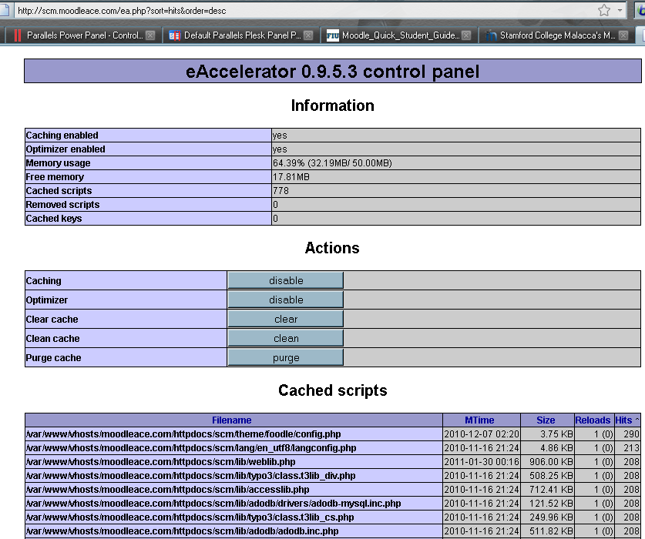
Figure 6: Screenshot shows caching of PHP pages working

On-the-fly-Compression of webpages via mod_deflate Apache module

Activating the mod_deflate module of Apache 2.2 allowed the author to enable server-side compression of web page data. The compressed data was then decompressed by client-side web browsers. This meant that now the loading time of the LMS was reduced by a factor of 30% to 80%. This translated into a faster surfing experience by the students. Certainly a crucial strategy in making the Moodle LMS more accessible to students and sweetening their experience. This compression was verified by a diagnostic website test at http://www.whatsmyip.org/http_compression/.
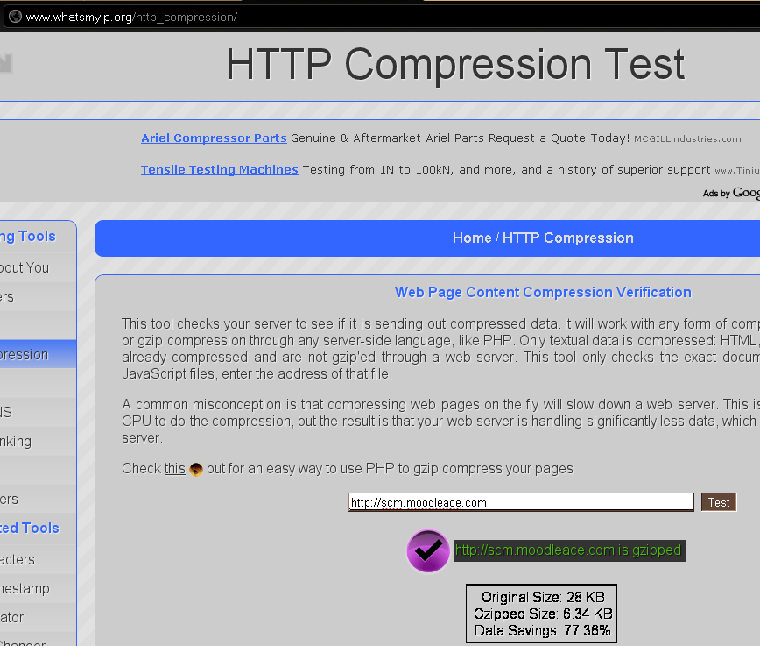
Figure 7: Evidence of web page pre-send compression (from 24kb to 6.34kb)

The websites that the author used to optimize the LMS’ response times were: http://www.websiteoptimization.com/speed/tweak/cache/
http://www.mydigitallife.info/2010/04/17/configure-and-enable-gzip-compression-with-mod_deflate-to-speed-up-apache-and-save-bandwidth/

Caching of of webpages via mod_expires Apache code. This allowed static content (e.g., image files and CSS files) to be cached by the Web Browser and only to be reloaded when the caching expired. This meant that the stress on the Server was reduced – less processor effort, and again, a faster server response time experienced by the user.
Apache optimisation

Apache settings were optimised for a 512Mb VPS to enable Apache to speed up the delivery of dynamic PHP content and to allow for more efficient usage of available Random Access Memory. On a side-project, the author installed the Munin plugin that allowed the author to monitor the VPS’s vital signs like memory usage, number of users logged in, uptime, downtime of server, number of processes and CPU usage. See the diagram below of the Munin graphs which were installed by him at the link http://www.Moodleace.com/ munin/ localhost/ localhost/ index.html#processes.
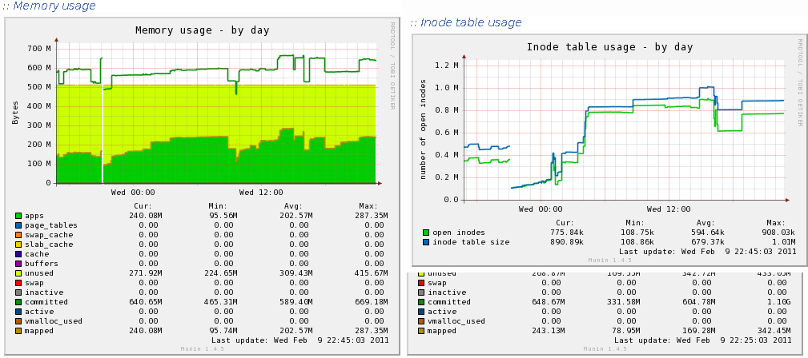
Figure 8: Screenshot shows evidence of Munin monitoring plugin in action.

MySQL optimisation

MySQL tables were optimised to ensure that the bottlenecks were removed. Indices of tables were also created where a table was consuming a lot of CPU processing effort. The link below gives the code to be used in the file /etc/conf/my.cnf that optimised the MySQL setup:
http://www.indiandevs.com/technoworld/2010/05/16/optimize-your-my-sql-databases-for-speed-increase-your-vps-performace-by-optimizing-mysql-databases/
Client-Side FireFox BetterCache addon

Client PCs in the computer laboratory were installed with FireFox 3.6.13 with the BetterCache addon. This addon helped to reduce Internet bandwidth by allowing the FireFox browser to reload the client-side cached data instead of requesting the data from the server. This addon was a God-send because it allowed web pages to load direct from Fire-fox’s cache data – which again enhanced the speed experience of using the LMS.
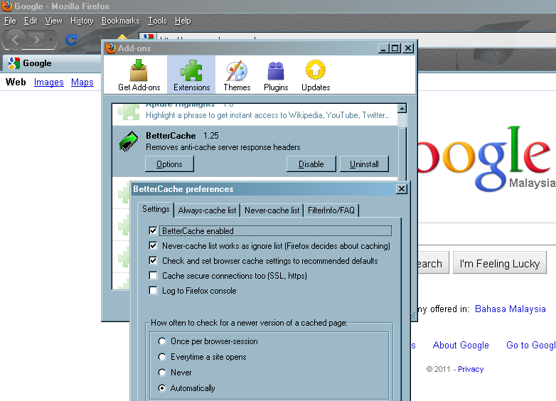
Figure 9: Screenshot shows the settings of BetterCache addon for Firefox.

Website Analyser services was employed to analyse the speed of the LMS. Specifically typed in the http URL of the LMS into these sites: http://gmetrix.com, http://www.webpagetest.org and http://siteloadtest.com. Based on the output from these websites, the author was able to tweak the various parts of the Moodle LMS in order to achieve faster speeds of page loads and reductions in waiting times. Refer to Figure 9, 10 and 11.

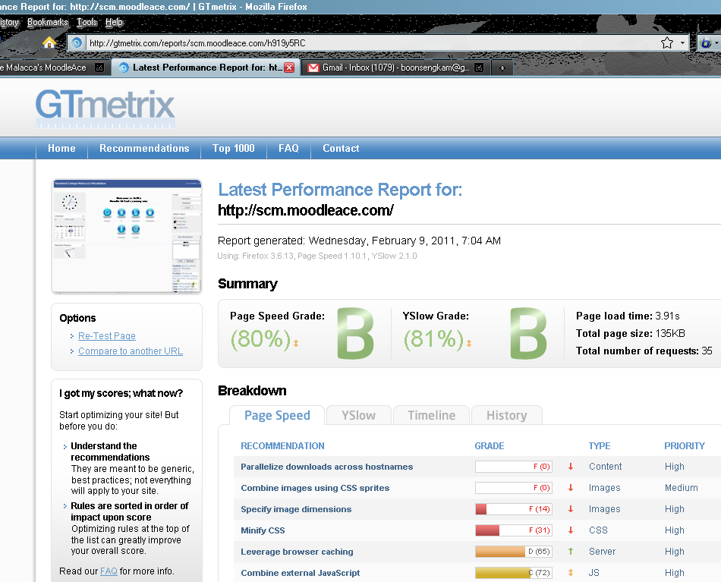

Figure 10: Screenshot shows the readings of Gtmetrix.com

The screen shows the the LMS received high scores of 80 and above for speed issues.

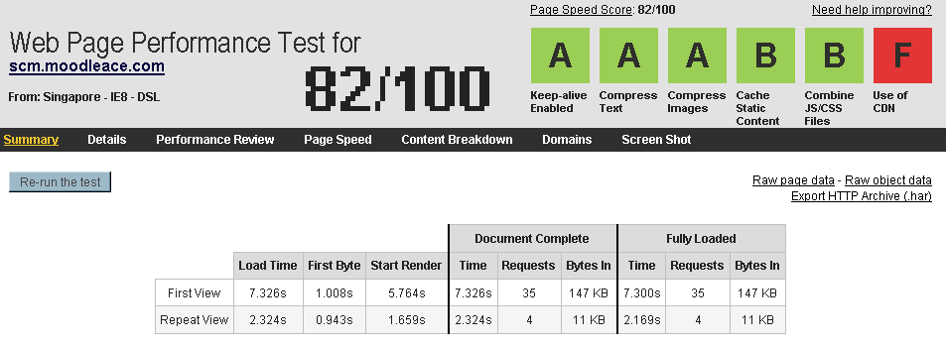
Figure 11: Screenshot shows the readings of http://webpagetest.org

The screen shows various grades achieved.
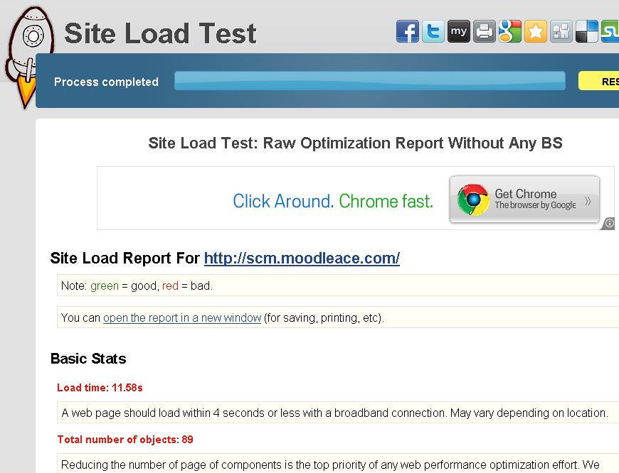
Figure 12: Screenshot shows LMS diagnosis of http://siteloadtest.com

3.1.2.3 Activities, modules and blocks of the LMS

Moodle came with a standard set of plugins that include modules (also known as activities), blocks and filters. They were divided into standard and non-standard modules. Table 8 shows the full set used at http://scm.Moodleace.com, with emphasis on some of the more useful ones:

Table 8: Moodle Plugins with Modules, Blocks and Filters
Type of  Plugin | Description of plugin
1. Filters | Filters allow for the automatic transformation of entered text into different, often more complex forms. For example the titles of resources can automatically become hyperlinks that take you to the relevant resource, URLs pointing to mp3 files can become Flash controls embedded in the web page that let you pause and rewind the audio. The possibilities are endless.
Nanogong | voice recording and playback of embedded voice data
Voicethread | short-form code of Voicethread object
Multimovie | Playback of various multimedia objects
2. Modules | Activities are things for students to do while logged into the course
Assignment | Students are able to upload file attachments
Attendance | Facilitator is able to keep an online attendance where percentage of attendance is automatically calculated
Book | A learning object that is menu-based to save vertical space – avoids the “scroll of death”. This module makes it easy to create multi-page resources with a book-like format.
Chat | The author used this module to have synchronous chat sessions with students. Sessions could be recorded.
Checklist | The author was able to create checklists as reminders for students to complete tasks
Choice | The author was able to create quick, mini questionnaires
Database | The Database module activity allows the teacher and/or students to build, display and search a bank of record entries about any conceivable topic.
easyVoter | This module mimics a real voter system – used to test students’ understanding
File | Allows multiple uploading of data files – used by me for file maintenance
Forum | An excellent form of asynchronous communication where students can answer topics by posting answers in forums.
Game | A series of popular games that draw questions from the quiz module. Snakes and Ladders,
Glossary | Lists terms and their meanings. Can be used to store images as well.
Hot Potatoes Quiz | A more flexible form of quiz which extends the functionality of the Moodle standard quiz.
Label | Allows me to create text, labels, images and any HTML code
Lightbox Gallery | A gallery of images is created from image files read from a folder
Media Player | A versatile multimedia object
Mindmap | Creates mind maps that are flexible

NanoGong | Students can be asked to respond to a question in the form of a voice recording.
Questionnaire | Allows complex questionnaires to be created. The Questionnaire module allows users to complete online feedback style forms using a variety of user input methods. It allows you to create your own questions, unlike the Survey module which has presets to choose from, and it allows for more advanced questionnaires than the simpler and easier Feedback module.
Quiz | Moodle’s standard quiz module
Stamp collection | An excellent form of motivation for students. The author was able to give out “Stars” as rewards for good behavior
Wiki | An asynchronous editable webpage. Allows sharing of ideas and creation of knowledge by various students
WiZiQ Live Class | I used this module to conduct a virtual class. Useful for part-time students.
3. Blocks | Blocks are data that is displayed in a section that is located on the right, centre or left hand side of the screen.
Active users | This allows me to see a list of users sorted by their active index.
Administration | Allows me, the Moodle administrator to do maintenance work on the LMS
Calendar | A useful administrative tool that students and lecturers can use to keep up to date with events. Customisable and events can added and edited.
Choose Theme | Allows users to change their theme – look and feel of the GUI.
Clock | A standard clock – the author used flash clocks to jazz up the look
Countdown | This block allowed me to create countdowns to important event (e.g., tests or exams)
HTML | Arguably the most useful block – allows me to embed HTML code (flash code, YouTube videos, any HTML or XHTML code)
Inactive Users | Shows me a list of students who have not been accessing the Moodle site
Latest News | Keeps students updated on any added activity by the Administrator
Login | A standard Login object
Login/Logout | Gives login information and shows a nice profile image of the user
Message My Teacher | Allows students to message their teacher
MultiMovie | A multimedia block
Online Users | A useful block that shows who has been online for the past X minutes or hours.
Online Users Map | Displays the global position of currently logged on users.
Progress Bar | Displays a list of mini-squares, which each square’s background colour in red, yellow or green. Green indicates that the activity has been completed, read indicates activities that the student has missed the deadline.
Quick Comments | Allows students to leave a comment for the lecturer of a course. The comment is sent via an email.
Quickmail | The author was able to use this useful block to email messages to students.
Quiz Results | This block was extremely useful in getting students to complete each quiz and to see who the top students of the quiz were as the scores are listed in descending order.
Random Glossary Entry | This block allowed me to create glossary entries of students’ images of themselves. A “Student of the Week” block was then created with the block displaying a different student each week.
Recent Activity | Shows recent activity in the course. Useful for the student to see what are the current things to be done.
Sharing Cart | This allowed the author to copy objects from one course to another.
Shoutbox | A mini-chat window that allowed students to post messages for all to see. Included fun things like posting of smilies.
Slideshow with Transitions | Allowed the author to create slideshows, with transitions, out of stored images.
Unanswered Discussions | Allowed the author to see at glance which discussion topics were “orphaned” – abandoned by students as none had posted a reply.
Upcoming Events | A reminder for students of coming tests with dates and times.
Use Stats For Teacher | Statistics for the teacher (facilitator) of the course.
Visitor  Counter | Keeps a count of visitors to the Moodle site.
YouTube Playlist | The author created several lists of YouTube videos that were displayed as a drop-down list.

3.1.2.4 Graphical User Interface
Theme Choice
To put the student at ease and to bring them into a familiar environment, initially the author chose the Foodle theme has the Facebook look in both colour and feel.
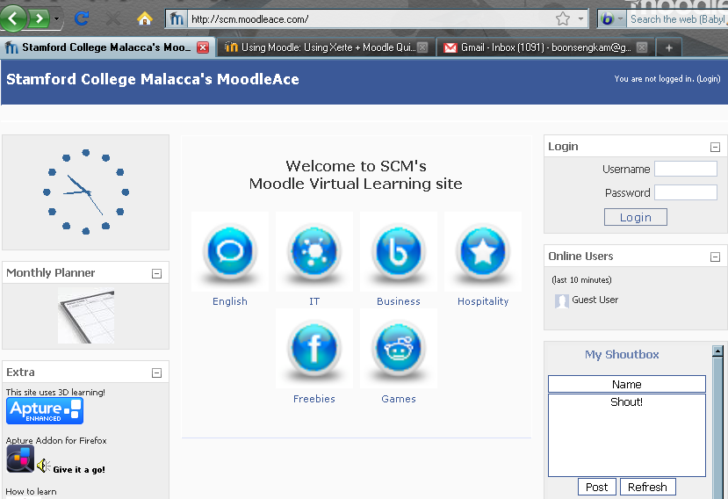
Figure 13 : Theme Choice

However, later the Isometric theme was chosen because its menu bar system allowed the user to quickly access a particular course.
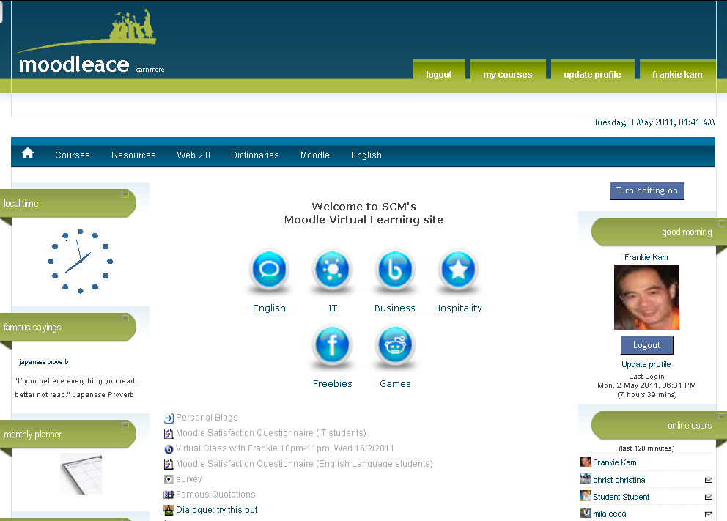

Figure 14 : Menu bar theme Choice
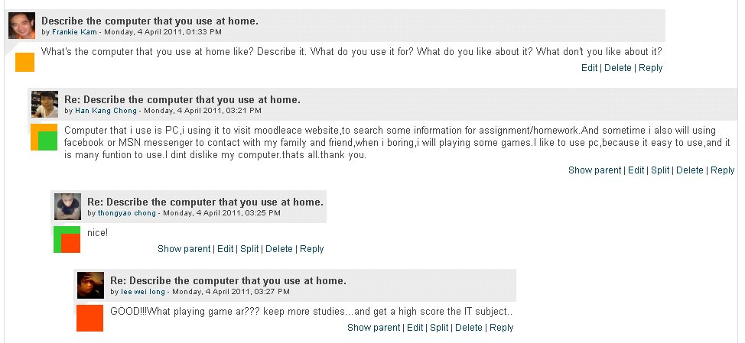
Figure 15: Hyper Forum page
Forums
Hyper Forum is an add-on that improves the readability of the Moodle forums. This allows users to be able to better follow complex threads. This is achieved by colour coding each post according the threads it is related to. Hyper Forum adds two coloured blocks onto each post. The first block indicates the parent of the current post, and the second indicates which posts are children (replies to) the current post.

Menu based system for easy access
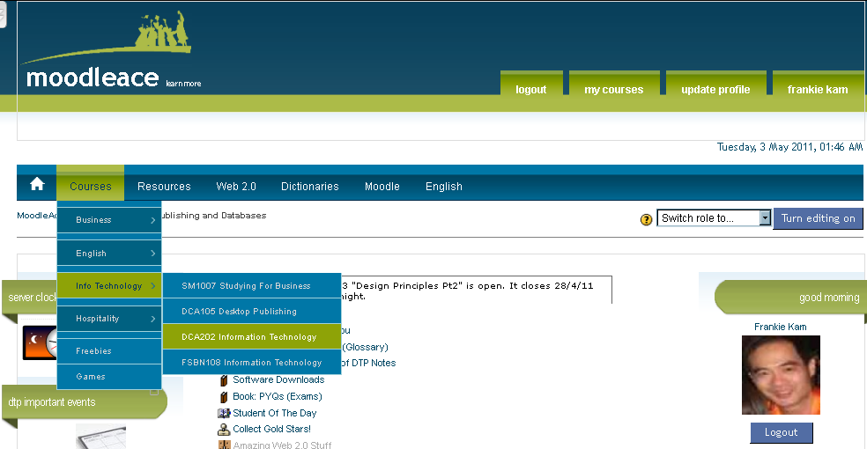
Figure 16: Isometric theme’s menu bar system
The menubar made it very easy for the student to access his or her course page.
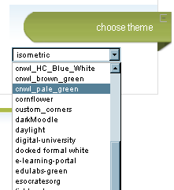
User Choice of Themes
A theme is design template that is applied to the entire LMS site. The LMS allowed the student user to choose his or her own theme of preference. The choice of theme decides the look, feel and colour of the interface.

Figure 17: Choose theme block

3.1.2.5 User Engagement
Moodle's standard Quiz module is a good assessment tool of students' understanding. However, by itself, the design is mainly text based in design and actual layout. To engage the student, a mash up of Exerted 2.15, Moodle's Quiz module and HTML Frame codes was created to achieve a new format of a quiz. It was created as a form of engaging the student with a multi-sectioned quiz screen. The quiz page was divided into 3 frames: Top frame = quiz page; Left frame = menu of video links; Right frame = resizable video screen.
The idea was to present quiz questions that were based on videos that the student can choose from the bottom left frame menu and view in the bottom right frame. The videos were either uploaded flv files or YouTube hyperlinks. The author found that he could test the student's understanding on what he or she had watched from the video, and the student never needed to leave the page since both the quiz section and the video sections were on the same screen. In addition, the user could resize the video section so that he or she could maximise the quiz frame area. The video could be replayed as often as long as the student did not run out of time on the quiz.
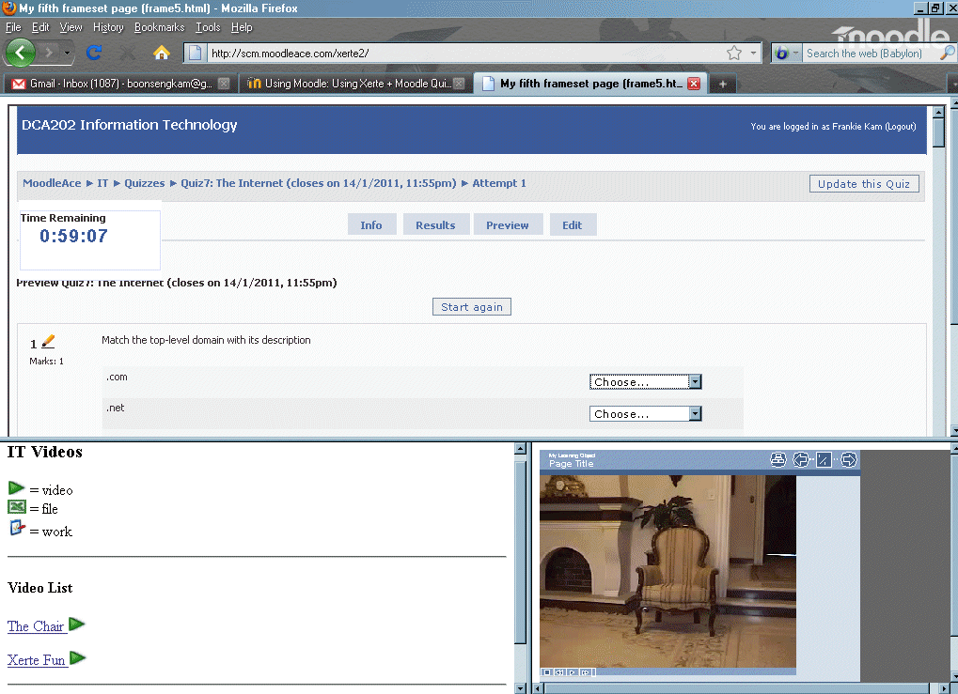
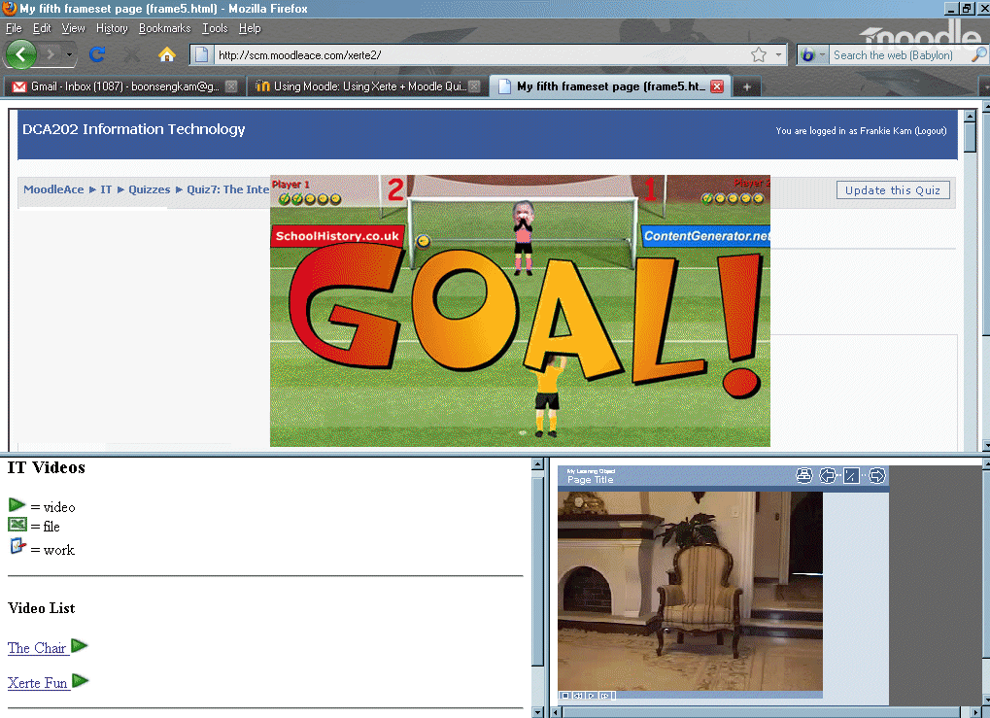

Figure 18: Engaging Quiz game Figure 19: Quiz with video segment

The results of the previous studies imply that video games can potentially have a positive impact on student achievement when students respond enthusiastically to the game (Gillispie, Martin, Parker, 2010). In view of this, the author also included the popular SCORM Flash games of http://contentgenerator.net in this mash up. The student received immediate feedback on the question answers. The student was engaged in learning and had fun trying to score the highest in the class for that game. The three games chosen to engage students were: Penalty Shootout, En Garde and Grade or No Grade.

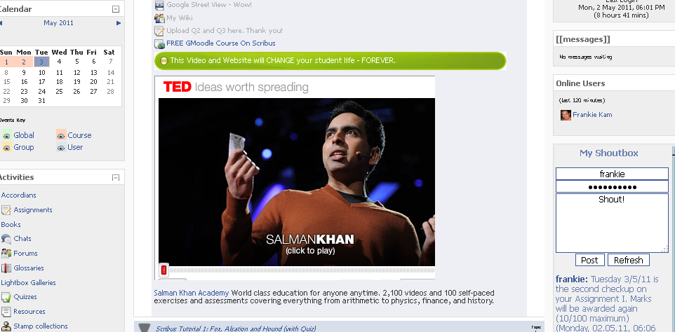
Abstraction in content

Figure 20: Use of Accordion Resource to avoid the “Scroll of Death”.
Note: the use of embedded Youtube allows video content to be viewed by the student.
Video tutorials
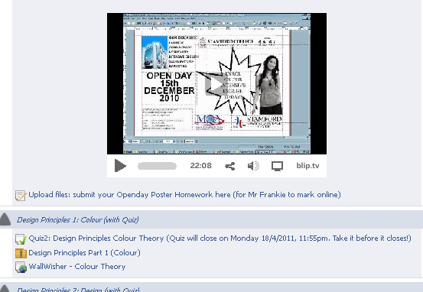
Figure 21: Use of Video Tutorials in learning application software
Video tutorials were embedded to provide visual-step-by-step instruction to the student.

Mind Maps
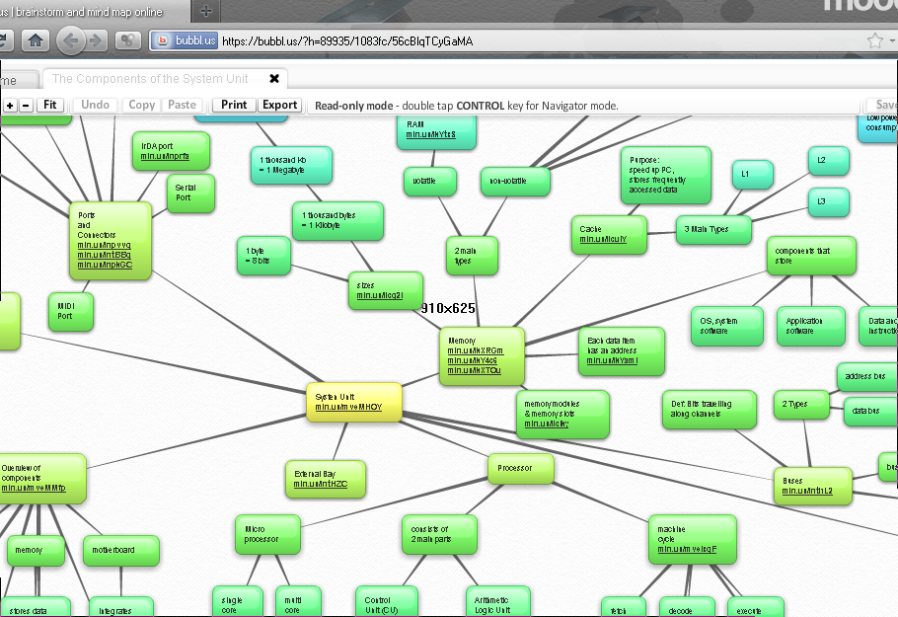
Figure 22. Use of Mind maps to abstract whole chapters
The Mind Map (http://bubbl.us) allowed the facilitator to structure the topics.

VoiceThreads

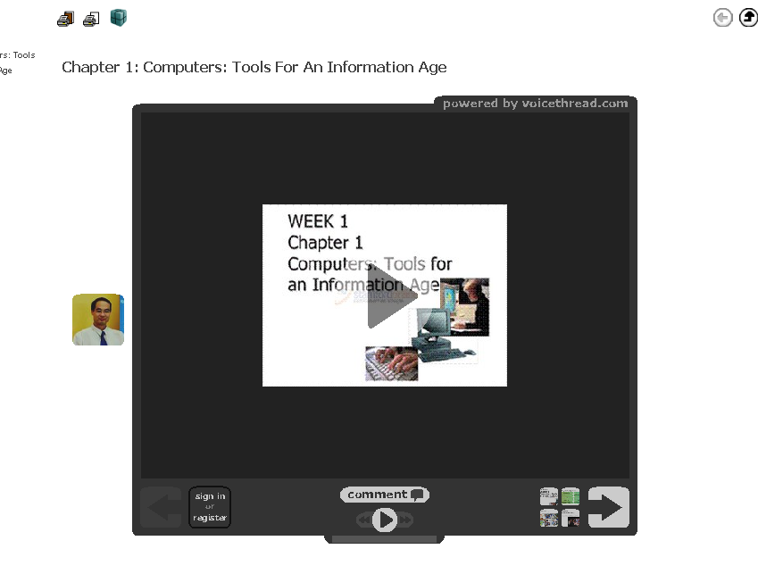
Figure 23: Use of embedded VoiceThreads

VoiceThreads allowed for video forums and asynchronous posting of text and voice comments. This was one Web 2.0 application that was a hit with the students.

3.1.2.6 Online course content

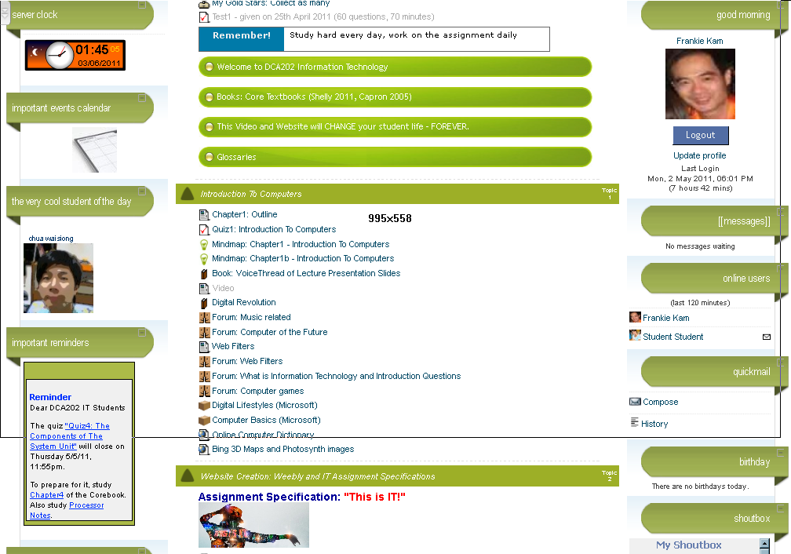
Figure 24: The DCA202 Information Technology course page.

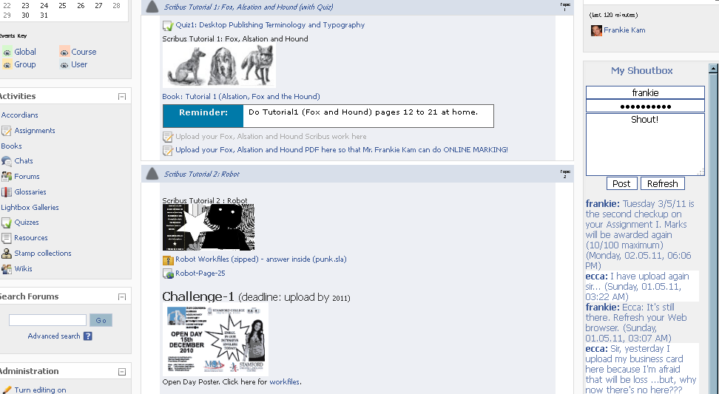
Figure 25. The DCA105 Desktop Publishing and Databases course page.
3.1.2.7 Methods of monitoring and feedback

Examination of Moodle Logs
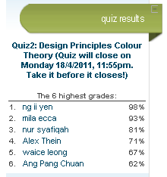
The screen below shows a typical examination of a student’s activity log which is easily available under Moodle’s Activity Reports module. To see the Quiz results block, look to the right of page.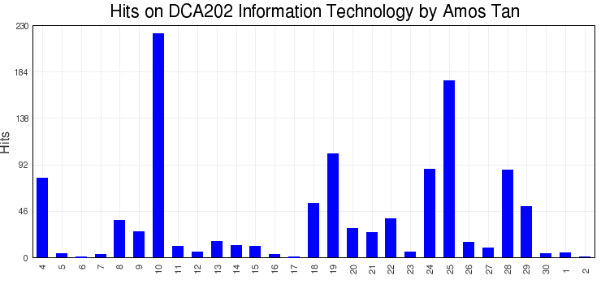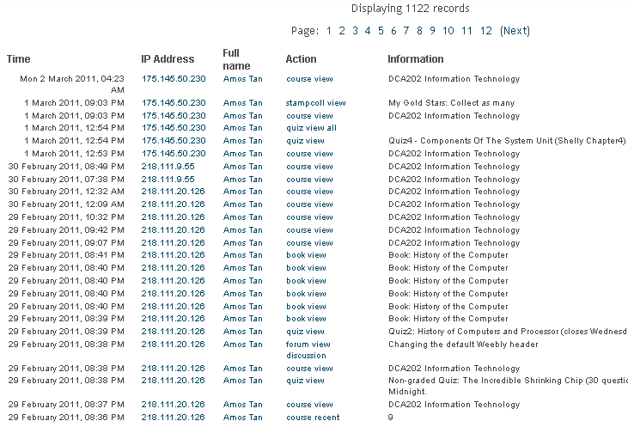
Figure 27: Time statistics (top right)
Figure 26: Monitoring of Moodle logs

3.1.3 Subjects of the research (participants)

The study was undertaken at Stamford College Malacca (SCM), one of the oldest private colleges in Malaysia, with over 60 years of experience in the education industry. They came from two disciplines, namely business (Diploma In Corporate Administration – DCA) and secretarial studies (Diploma In Executive Secretaryship). The DCA students were enrolled in the DCA105 Desktop Publishing And Databases course (23 students) and the DCA202 Information Technology course (6 students). The DES students were enrolled in the DES1203 Computer Applications In The Office course (10 students).

3.1.4 Research Instrument

To determine the effectiveness of the LMS in shaping the students as per the objectives stated earlier in this document, a 27-part questionnaire was used for this study. It was given out in the middle of February 2011 to the students after four months of semester studies. Their studies entailed them logging onto the Moodle LMS and conducting their activities and homework online. The questionnaire was based on a 5-point Likert Scale and the students were informed not to write their names on the sheet, and they were informed that their responses were confidential. In addition, they were informed that their responses would in no way affect or influence their examination marks in March 2011.
The results were then entered into the Moodle Questionnaire activity (located at http://scm.moodleace.com/mod/questionnaire/view.php?id=2034) by their facilitator (me). Tables were then generated by the Moodle Questionnaire and the Likert scores were summarised into a mean value for each relevant question. The individual results were also entered into Excel for tabulating of totals, averages, and standard deviations. Histograms were then produced from the same software. SPSS was not used for these two reasons: the sample size, at 39, was considered small, hence Excel was more than capable of delivering processing the data. The second reason was the unavailability of a valid licensed copy that could be used at the college to tabulate the scores and to produce the results.

CHAPTER 4 - RESULTS AND DATA ANALYSIS

4.1 Questionnaire Used

To gauge the students’ response to the Moodle site http://scm.Moodleace.com, the author designed and distributed the following questionnaire. The number of respondents was 39 students. The breakdown of (n): DCA105 (6), DCA220 (23), DES1203 (10)
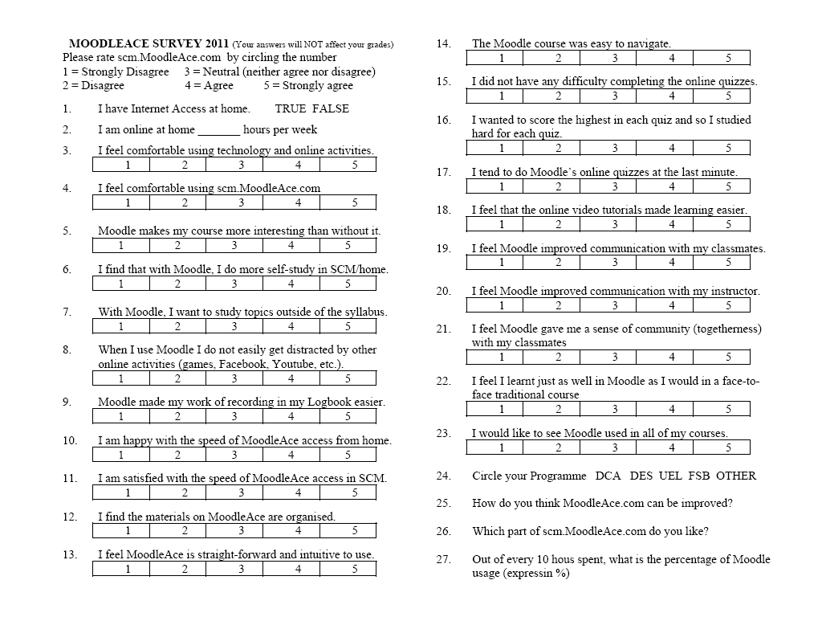
Figure 28. Questionnaire
4.2 Overview of the Likert Scores

Value in brackets indicates the mean respondent score.

Q1. I have Internet Access at home (Yes = 85%, No = 15%)
Q2. I am online at home _______ hours per week (majority stated 7 hours @ week)
Q3. I feel comfortable using technology and online activities. (3.6)
Q4. I feel comfortable using scm.MoodleAce.com (3.4)
Q5. Moodle makes my course more interesting than without it. (3.4)
Q6. I find that with Moodle, I do more self-study in home. (3.4)
Q7. With Moodle, I want to study topics outside of the syllabus. (3.2)
Q8. When I use Moodle I do not easily get distracted by other online activities (games,
Face book, YouTube, etc.). (2.8)
Q9. Moodle made my work of recording in my Logbook easier. (3.4)
Q10. I am happy with the speed of MoodleAce access from home. (3.5)
Q11. I am satisfied with the speed of MoodleAce access in SCM. (3.1)
Q12. I find the materials on MoodleAce are organised. (3.3)
Q13. I feel MoodleAce is straight-forward and intuitive to use. (3.4)
Q14. The Moodle course was easy to navigate.(3.3)
Q15. I did not have any difficulty completing the online quizzes. (3.3)
Q16. I wanted to score the highest in each quiz and so I studied hard for each quiz.(3.6)
Q17. I tend to do Moodle’s online quizzes at the last minute. (2.9)
Q18. I feel that the online video tutorials made learning easier. (3.6)
Q19. I feel Moodle improved communication with my classmates. (3.3)
Q20. I feel Moodle improved communication with my instructor. (3.4)
Q21. I feel Moodle gave me a sense of community (togetherness) with my classmates
(3.3)
Q22. I feel I learnt just as well in Moodle as I would in a face-to-face traditional course
(3.2)
Q23. I would like to see Moodle used in all of my courses. (3.3)
Q24. Select your Programme (DCA=62%, DES=38%)
Q25. How do you think MoodleAce.com can be improved? (Quiz majority)
Q26. Which part of scm.MoodleAce.com do you like? (quiz the most)
Q27. Out of every 10 hours spent on this subject, what is the percentage of Moodle
usage. (express in %) (30% majority choice)

4.3 Detailed Analysis of Each Result of the “Does Moodle Make A Difference In
Your Self-Studies?” Questionnaire.

4.3.1 I have Internet Access at home
Purpose: To determine the demographics of the students’ Internet Access.
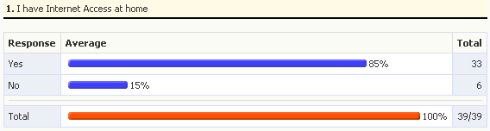
Figure 28: I have Internet Access at home

Observation
The majority of students, 85%, had Internet access at home. This was crucial to the success of the project as it allowed 33 of the students to access the LMS at the comfort of their homes. The remainder 6 students were not frequent computer laboratory users. Hence they did not actively engage themselves in the LMS work. A check on the computer laboratory logbook showed that the six Internet-access-less-students only logged on during the scheduled three to four hours of class time. When asked about this, four of the six students responded that they went to their friend’s house to use the LMS.
4.3.2 I am online at home ____ hours per week

Purpose: To gauge the amount of time spent engaging in the LMS.

Figure 29: I am online at home ____ hours per week
σ (Standard deviation) is 20.37, (mean) is 16.84

Observation
The majority of students, 79%, stated that they spent at least 30 hours online per week. This worked out to a mean of 4.28 hours per day which is very high. The σ is on the high side as the number of hours was either very high or very low. (mean) is 16.84 hours spent per week. The students are expected to spend between 6 to 8 hours of study, based on a 2:1 ratio of SLT to scheduled class time. = 16.84 is too high and the results were over-optimistic.
4.3.3 I feel comfortable using technology and online activities.

Purpose of question
To gauge the students’ overall acceptance of technology and going online.
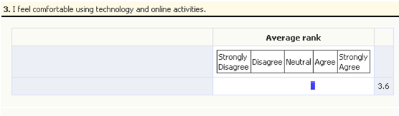

Figure 30: I feel comfortable using technology and online activities.

Observation
The histogram is skewed to the right. This suggests that the majority 52% of the students had no problems using online technology. This is expected of Generation Y, and is consistent with the characteristics of the Net Generation (Oblinger, 2004).

4.3.4 I feel comfortable using scm.MoodleAce.com

Purpose of question
To see the level of user-acceptance of the Moodle LMS at SCM. After much technical work and course planning had gone into the project, it was imperative that the students be comfortable using the system.
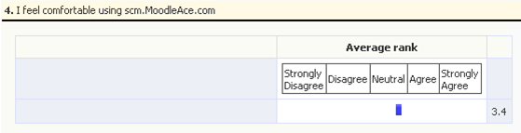

Figure 31: I feel comfortable using scm.MoodleAce.com

Observation
The histogram is skewed to the right. This suggests that a majority of 40% of the students were at ease in using the LMS. The related factors were speed of page loads, user-friendliness, ability to do self-assessment and orderly organisation of information.

4.3.5 Moodle makes my course more interesting than without it.

Purpose of question
To see if the blended approach of studying could liven up the course, as compared to just having traditional face-to-face classes. If the online activity which was meant to supplement, and not to replace, the traditional classes, deemed to be interesting by the students, then it could translate into more time spent online on the site.
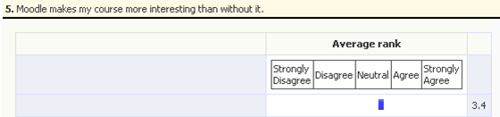

Figure 32: Moodle makes my course more interesting than without it.

Observation
The histogram is skewed to the right. This suggests that a majority of 41% of the students found the LMS made the course more interesting than without the LMS.
4.3.6 I find that with Moodle, I do more self-study in home.

Purpose: This KEY question was to determine if the blended approach of studying had caused the student to do more self-directed learning in a venue outside of the college. The results would indicate a direct bearing of the LMS on their study time and habits.

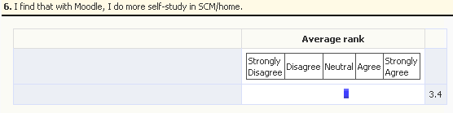

Figure 33: I find that with Moodle, I do more self-study in home.

Observation
The skew to the right suggests that a majority of 44% of the students found that the LMS brought about an increase of out-of-class self-study hours. This was most probably due to the fact that most of the material online was not existing in hard-copy format. The course was online-based in content as the quizzes and lecture flash presentation slides were only accessible online. The most amount of time was spent on quiz-preparation and quiz-taking by the students.

4.3.7 With Moodle, I want to study topics outside of the syllabus.

Purpose: To know if the students’ thirst for knowledge would be increased until a stage where they would read outside of the basic syllabus. The Apture context-sensitive help made it possible for students to search for information within the LMS itself.
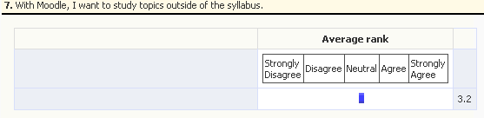

Figure 34: With Moodle, I want to study topics outside of the syllabus

Observation
The skew to the right suggests that a majority of 29% of the students did attempt to study topics outside of the syllabus. Some gave excuses: “I just did the minimum expected work due to time limitations and demands from other business courses”. In addition, the “disagree group” students preferred to do what was instructed, an not what was expected. The Apture addon which allowed context help within the LMS was helpful to some.
4.3.8 When I use Moodle I do not easily get distracted by other online activities (games, Facebook, YouTube, etc.).

Purpose: Being online in nature, time spent accessing the LMS has the danger of online distractions. For example Facebook, YouTube, Twitter and online Role-Playing-Games. This question was for the student to reflect and honestly decide to what degree online activity outside of the LMS was affecting quality-college-related self-learning time.
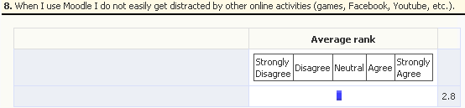

Figure 35: When I use Moodle I do not easily get distracted by other online activities

Observation
The histogram is skewed to the left. This suggests that a majority of 36% of the students found that they were able to focus on the LMS during the time spent on their homework or self-learning time. Among the distractions were Facebook, YouTube and other Web 2.0 sites. This result is directly related to Question 5.
4.3.9 Moodle made my work of recording in my Logbook easier.

Purpose: To see if the Moodle weekly format of the course page would help students to keep track of their class activities, and in so doing, make it easier to fill in their logbooks on a daily basis.
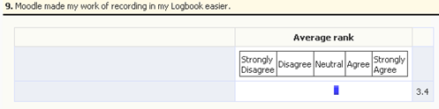

Figure 36: Moodle made my work of recording in my Logbook easier.

Observation
The heavy skew to the right of the Neutral choice suggests that the LMS did make a significant difference in helping students to recall the previous days’ learning activities. The students could refer to their activity logs to recall or to retrace the work that they did online. In addition, the Calendar Planner block kept a record of the salient parts of the course. Students were able to refer to these when filling in their logbooks.
4.3.10 I am happy with the speed of MoodleAce access from home.

Purpose: To see the students’ perception of the LMS speed when accessing from home. A website that takes more than 4 seconds to load, on the average, will lose 33% of its first time Web surfers (Akamai, 2006). Slow load times lead to rejection of the LMS.
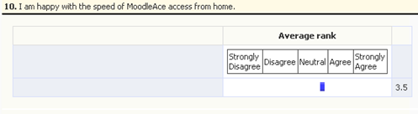

Figure 37: I am happy with the speed of MoodleAce access from home.

Observation
The skew to the right of the Neutral choice suggests that the majority of 46% users were happy with the load times and speed of the LMS. This result is expected to be better than Q11 as each home PC is connected to an individual Streamyx line. The home surfing experience is faster compared to 20 computer laboratory users connected to the LMS. This proves that the hard work to optimise the LMS had paid off.
4.3.11 I am satisfied with the speed of MoodleAce access in SCM.

Purpose: Initially slow page load times and connection timeouts were the sore points of the LMS. This question was important as it would establish whether the students could comfortably access the LMS simultaneously in a group, without experiencing too much frustration or disruptions. Would the two months spent optimising the website pay off?
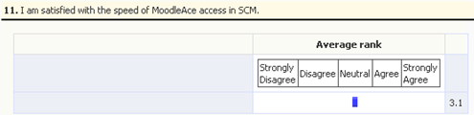

Figure 38: I am satisfied with the speed of MoodleAce access in SCM.

Observation
The slight skew to the right suggests that a majority of 39% of the students felt that the LMS access in the computer laboratory was fast enough. However, as expected, here there are more dissatisfied users compared to the home surfing scenario. This is because the single ADSL Broadband line of the college was shared among 21 concurrent users.
4.3.12 I find the materials on MoodleAce are organised.

Purpose: To see if students perceived the LMS as organised. This had a bearing on the ease of locating the necessary resources and activities within the course pages.
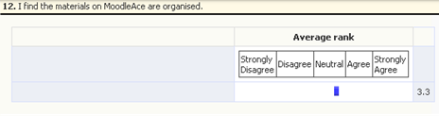

Figure 39: I find the materials on MoodleAce are organised.

Observation
The slight skew to the right suggests that students found the activities on the course page to be are organised, but not in significantly large numbers as the author had hoped. This is an area that needs to be addressed in the future. Upon interviewing the students, a main reason that was mentioned was that the course page was “cluttered” with too many individual activities, and sometimes it was difficult to separate the “trees from the forest”, so to speak.

4.3.13 I feel MoodleAce is straight-forward and intuitive to use.

Purpose: To find if the students perceived the LMS as user-friendly and easy to use.

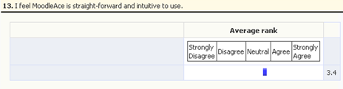

Figure 40: I feel MoodleAce is straight-forward and intuitive to use.

Observation
The histogram is heavily skewed to the right. This suggests that students tend to find that the activities on the course page are easy to use as the facilitator had hoped. The findings in this question are related to the perceived organisation of the LMS as indicated in Question 12 of the previous page.

4.3.14 The Moodle course was easy to navigate.

Purpose: To find how the students perceived navigatability. The LMS had a bread-crumb feature that allowed the user to make his or her way about in the system.

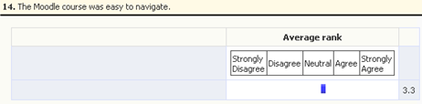

Figure 41 : The Moodle course was easy to navigate.

Observation
The significant skew to the right suggests that the 16% majority of students had no problems moving around the site. Customising one’s own theme also helped. There were no complicated procedures as most actions were merely point-and-click.

4.3.15 I did not have any difficulty completing the online quizzes.

Purpose: To see the perceived ease-of-use of the students of quiz activity which was conducted in the comfort of the home. This activity was beyond the facilitator’s control. The quiz was open to possible disruptions such as loss of data transfer, user session timeouts or results of questions not being recorded in the server.

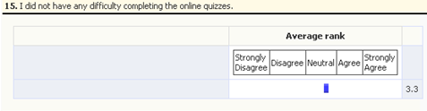

Figure 42 : I did not have any difficulty completing the online quizzes.

Observation
The skew to the right shows that most did not have any major problems taking the quizzes. Eight students faced problems. Upon interviewing one student, he commented that his PC hung during the quiz. The quiz was set to display only 5 questions per screen to reduce the load on the LMS’ Apache Server. So quiz failure could happen due to a glitch on the student’s PC or poor Internet connection.
4.3.16 I wanted to score the highest in each quiz and so I studied hard for each quiz.

Purpose: To find the degree of factor of each student for completing each quiz, and to determine how seriously the students treat the graded quizzes.

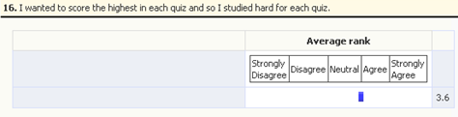

Figure 43: I wanted to score highest in each quiz and so I studied hard for each quiz.

Observation
The significant skew to the right suggests that the quiz had an effect of forcing the students to study material that they would have otherwise have left to the end of the semester, had there been no quiz. The finding here appears to correlate to research that formative assessment, as in this case, where students had to take six Moodle quizzes in a semester, has a greater impact on shaping a student’s understanding than summative assessment, as in a final semester exam (Harlen, James, 1997).

4.3.17 I tend to do Moodle’s online quizzes at the last minute.

Purpose: To study the quiz-taking habits of the students, and to see if the students were taking the quizzes at the last-minute or at a controlled pace. The quizzes closed at midnight, four to five days after being opened. Up to three attempts were allowed.

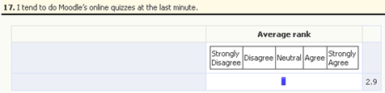

Figure 44 : I tend to do Moodle’s online quizzes at the last minute.

Observation
The balanced histogram suggests that most students took the quiz at the last minute. 64% were honest enough to answer openly. Half indicated that they had some control over their quiz-taking. The other half were either lazy or procrastinators.

4.3.18 I feel that the online video tutorials made learning easier.

Purpose: To study the effect of the LMS’ embedded video tutorials, on the students’ learning processes. Specifically, in the area of mastering application software skills.

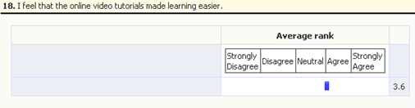

Figure 45 : I feel that the online video tutorials made learning easier.

Observation
The significant skew to the right suggests that the students received much benefit from the video tutorial sections of the LMS. This is in harmony with the study done (Pang, 2009), that reveals that video-driven multimedia and web-based instruction was pedagogically equivalent in terms of knowledge gained in live instruction.

4.3.19 I feel Moodle improved communication with my classmates.

Purpose: To study the effect of the LMS’ internal messaging (IM) system on the students’ learning experience. Was it a nuisance or a useful tool?

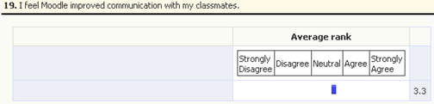

Figure 46 : I feel Moodle improved communication with my classmates.

Observation
The skewed to the right shows that students enjoyed the Instant Messaging (Lancaster, et. Al. 2007). The students did feel that the Login Users block that displayed the currently online users, and the Shoutbox block, that allowed them to post instant messages to a block, were useful. Forums that allowed asynchronous messages were also well received. Moodle’s chat activity was not popular because it was not embedded inside a page. Students preferred to use their Facebook Chat to collaborate instead.

4.3.20 I feel Moodle improved communication with my instructor

Purpose: To determine the degree of usage of the LMS’ communication tools (forum, chat, instant messaging system, wiki) in students’ communication with the facilitator.
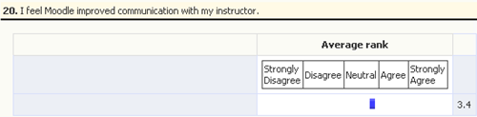

Figure 47 : I feel Moodle improved communication with my instructor

Observation
The skew is to the right. Students often posted messages on the Shoutbox block and the author regularly replied to them. The students seldom instant messaged him. Perhaps the students mostly accessed the LMS during the late night and early morning hours and were shy to IM the author (since they ought to have been sleeping at that “unholy hour”). Likewise the author at times felt a bit awkward to IM his students at those times. Another communication tool was the Forum discussion groups. However, these were useful only for a specific period of time, as in during assignment releases.

4.3.21 I feel Moodle gave me a sense of community (togetherness)

Purpose: To determine if the LMS had achieved a sense of online community amongst the student users.

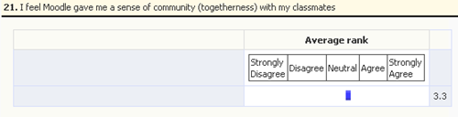

Figure 48 : I feel Moodle gave me a sense of community (togetherness)

Observation
The skew is mostly to the right. This suggests that the students considered the LMS to have fostered an online community (OC) of users. Definition of OC: “any group of people who use Internet technologies to communicate with each other” Preece, Malony-Krichmar, 2005). Even in the comfort of their own rooms, the students connected through the forums and Shoutbox postings.
4.3.22 I learnt just as well in Moodle as I would in a face-to-face traditional course

Purpose: To know if the student could learn the course by Moodle without the face-to-face contact. The test the effectiveness of the LMS over face-to-face traditional course.

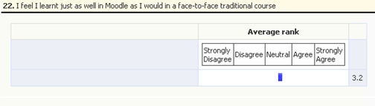

Figure 49 : I learnt just as well in Moodle as I would in a face-to-face traditional course

Observation
This histogram is mostly skewed to the right. The student responses indicate that LMS-based instruction, cannot substitute a live instructor. Research by other researchers have revealed that e-learning can be at least as effective as conventional classroom learning under certain situations (Dongsong, et.al., 2004). The result shows that e-learning cannot and will not replace traditional classroom learning at SCM, any time soon.
4.3.23 I would like to see Moodle used in all of my courses.

Purpose: to see if the student acceptance of the LMS could extend to other courses.
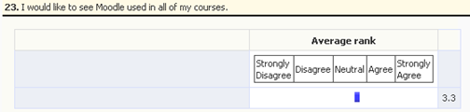

Figure 50: I would like to see Moodle used in all of my courses.

Observation
The skew to the right indicates that the students would like to have more online courses. The responses to this question were interesting as there were nine students (23%) who do not agree to have their courses virtualised. Out the nine students, six of them are without home Internet access, and three were of the opinion that they did not want to spend so much time in front of the computer. Overall, the opinion was that the more online courses, the better.

4.3.24 Select your Programme

Purpose of question
This question was to see the breakdown of students according to their programmes.
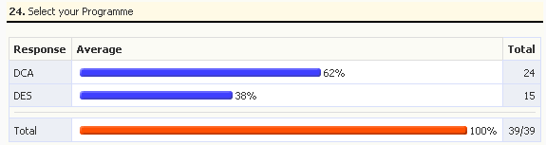

Breakdown of student respondents by Programme

Figure 51 : Programme breakdown of student respondents

Observation
The largest number of students came from the DCA programme whilst the remainder were Secretarial students.

4.3.25 How do you think MoodleAce.com can be improved?

Purpose: to receive suggestions from the students with regards to the LMS.
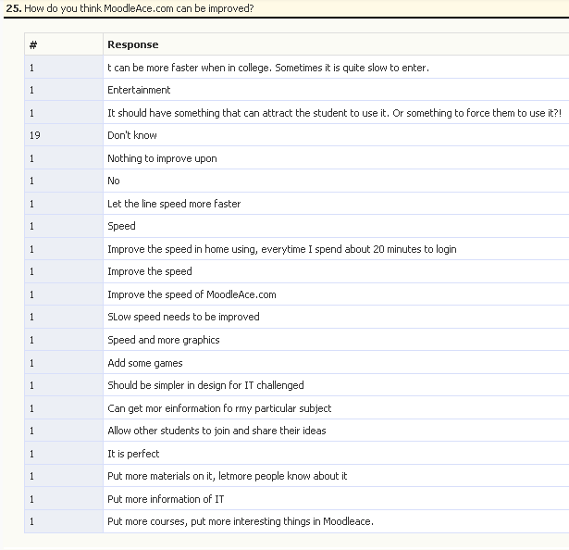

Figure 52 : How do you think MoodleAce.com can be improved?
Observation: The chief need among students was the speed factor. 21% felt that the system should be faster. 49% did not comment.
4.3.26 Which part of MoodleAce.com do you like
Purpose: To elicit ideas and suggestions from the students.
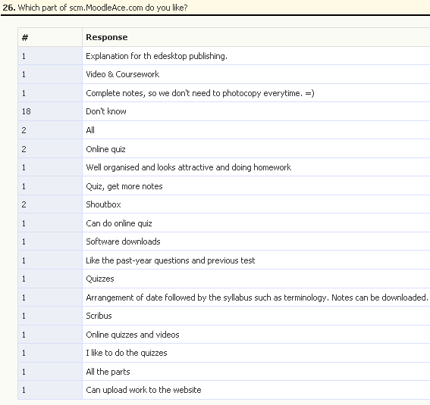

Figure 53 : Which part of MoodleAce.com do you like
Observation – among those who had something to say, the liking for quizzes stood out.
4.3.27 Percentage Moodle Usage

Purpose: To see the percentage of online time spent on the LMS.
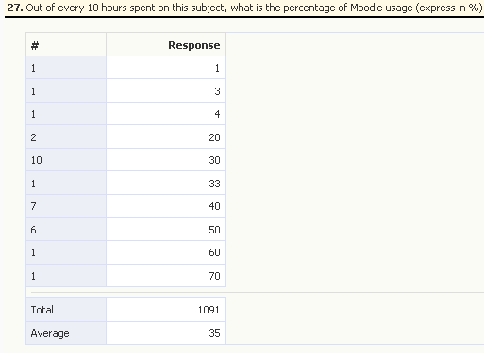

Figure 54: Percentage Moodle Usage in %

Observation
The majority of students estimated that Moodle learning time and engagement took up to 30% of their total learning time for the Information Technology programme.
4.4 Time spent online versus versus higher quiz scores (Mean scores of Quiz1, Quiz2 and Test1)
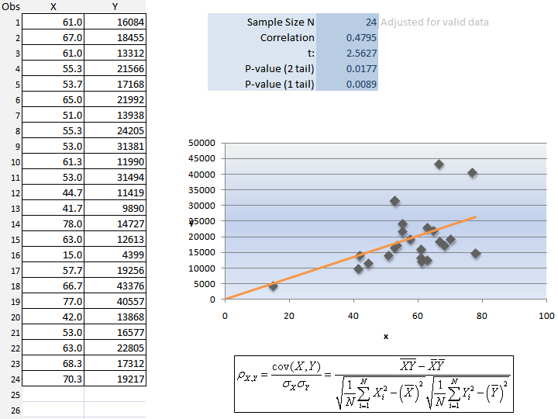
In the April 2011 short semester (4/4/2011 to 27/5/2011), 23 IT students were told that the author would test the link between spending more time online on the LMS and getting a higher grade. Over a period of four weeks, three online quizzes were conducted. The scores were recorded in the LMS. The total time spent online per student was also collated by a third-party block named the Timestat block. Below are the results of the quizzes, correlated with the amount of time (seconds) spent during a specific date range. The mean score of Quiz1, Quiz2 and Test1 were correlated to the amount of time spent online on the LMS from 4/4/2011 to 30/4/2011. P-values are less than 0.05. This means a rejection of the null hypothesis, H₀.
All quizzes and tests were multiple choice questions, true or false, matching and sequencing type of Moodle quiz online questions.
Q1,Q2, Test mean Secs online

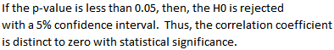
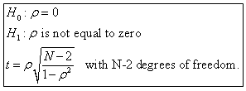
Figure 55: Overall correlation
Figure 54 : % Moodle Usage

4.5 Time spent online versus higher scores (Quiz 2)

The student scores of Quiz1 were correlated to the amount of time spent online on the LMS from 4/4/2011 to 14/4/2011. P-values are < 0.05 rejection of H₀. 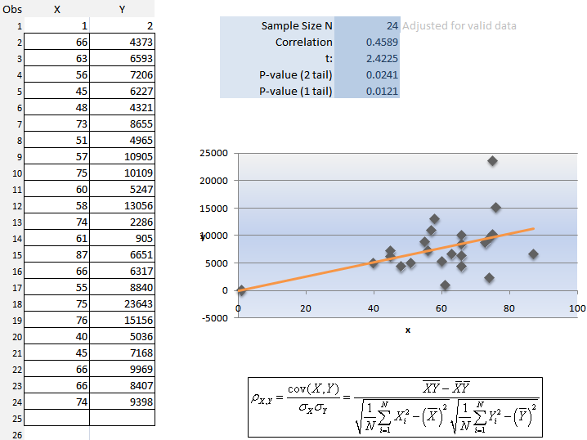
Quiz1 Secs online
Figure 56:
Quiz1 correlation

The student scores of Quiz2 were correlated to the amount of time spent online on the LMS from 14/4/2011 to 19/4/2011. P-values are < 0.05 rejection of H₀.
Quiz2 Secs online
Figure 57: Quiz2 correlation

The student scores of Test1 were correlated to the amount of time spent online on the LMS from 20/4/2011 to 25/4/2011. P-values are > 0.05 acceptance of H₀ (!) The result of this Test shows a negative correlation and the P-values are not less than 0.05. A possible reason for this anomaly is due to the nature of Test1. Test1 was different from the other quizzes in that it was conducted during college hours in the computer lab. Time was restricted to 70 minutes for the quiz. There was no chance of collaboration among students as the questions generated were randomised. Unlike Quiz1 and Quiz2, each student’s score was taken only from the first attempt. The students were under a different pressure here. Whereas when the quiz was taken at home, they could do their preparations at a more relaxed pace and choose to retake the quiz three times in a row, with the mean score being recorded.
Q1,Q2, Test mean Secs online
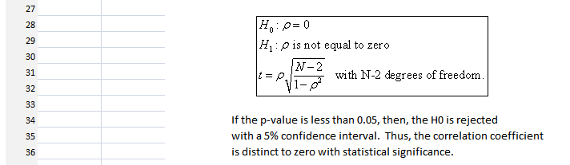
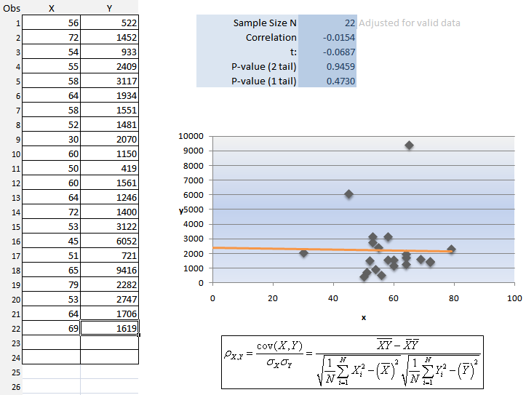
Test1 Secs online

Figure 58:
Test1 correlation

CHAPTER 5 - DISCUSSION

5.1. Summary of main findings
From the data it showed that students were spending more time being engaged in online learning. In this section, I summarise my experience and findings of the research.
First I would like to review the Questionnaire data by providing an overview of the scores of each equation. The feedback from the students based on the questionnaire given is summarised in an overview below:
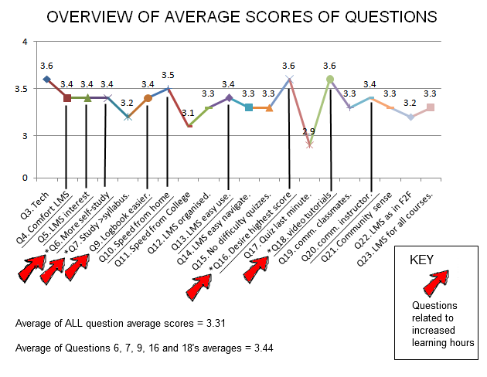
Figure 59: Overview of Mean Scores
The overall score (i.e., the mean of means) was 3.31. Of particular interest were Q6 (more self-study), Q7 (desire to study beyond the syllabus), Q9 (makes filling in the logbook easier), Q16 (trying to outdo their classmates in quiz score rankings) and Q18 (liking for video tutorials as a chief means of Ms. Office software mastery).
These were IT-related questions and they provided a mean of means score of 3.44. The author interprets these scores as being more than the mid-way-point of 3.0 out of 5.0.
The author deduces that there has been an slight increase in Self-Directed-Learning among the students, but not equally among all students. This is because in every graph, the largest number of respondents was in the “Neutral, 3 point score” on the Likert Scale! This was probably due to the respondents themselves – either they did not fully understand the meanings of the questions or they misinterpreted them. Poor grasp of the English language could have been the reason for some. In others it could be due to laziness or the need to “get the Questionnaire out of the way as soon as possible”.
At the beginning of the project the author’s hypothesis was that given a working LMS and under proper guidance and monitoring, students’ SDL hours would increase. That it has increased is based on the right-skew of practically all the graphs, although it can be argued that the population size (n=39) was small. The author believes that SDL has increased due to the following factors:
- More online Moodle activities to engage the student (quizzes, videos, games, chat);
- It allowed them to fill in their logbook easier as they had the LMS to refer to;
- Closer monitoring of their logbook by the individual lecturers;
- A sense of online community where the LMS was furnished with Web 2.0 features;
- Flash-based PowerPoint slides in full colour, whereas their notes were in B&W;
- Apture context pop-up searches made for a more engaging experience on the LMS;
- Student’ scores were put online – this generated healthy competition among the students. Hence, there was a slight correlation between times spent online doing college-related SLT, and higher Quiz scores.
- Regular feedback by the author to keep the communication flow current and alive.
The author chose the Moodle LMS because of the challenge to increase Student Self-Directed Learning among the Diploma students of SCM as well as to find a vehicle by which the very same students could be engaged in effective online learning activities. The solution was a long-time coming as far as the college was concerned.
The entire process and project was one that was never easy from the start as it involved a heavy dose of server administration to overcome the technical problems to win over students’ acceptance of the system. It took more than four months for the system to become stable in terms of functionality and speed responsiveness. Increasing the speed of the LMS’ response time was the biggest challenge and the system’s Archilles Heel.
Another major constraint was the budget given which was generously donated by the Principal of SCM, Mr. K. Narayanasamy. This was a one-time investment which I had to work with and not request for more financial aid whenever I hit a brick-wall in my attempts to increase the speed of the system. It also was through many attempts and searches on Google.com by using the keywords “VPS optimisation” and “Speeding up Moodle” that the author was able to achieve a breakthrough. The breakthrough being defined as having a system that allows 20 to 25 simultaneous online student users to access the site with a mean lag time of not more than 5 to 6 seconds per screen refresh.
The technical success of the system can be attributed to these factors:
- Aggressive and determined searches on Google.com to find out solutions;
- Server-side compression of web page code to reduce website load-times
- PHP acceleration of PHP object code which reduced the load of the server’s processor load due to multiple similar client PC requests
- Optimisation of Apache settings as gleaned from the Net
- Optimisation of MySQL database settings as gleaned from the Net
- The flexibility of Moodle 1.9.7 Open Source LMS
- The various posts and response the author received from the Moodle online community, chiefly from the forums on http://moodle.org.
An interesting outcome of this research project is the correlation results of Test1 which was conducted wholly on-campus. The results of Quiz1 and Quiz2 were as expected, with the data and graphs showing a correlation between amount spent online on the LMS and higher grades.

5.2 Conclusion

The author set out to determine if the usage of a LMS, specifically a LMS consisting of Moodle Version 1.9.7, could make a difference in getting students to do more Self-Directed Learning. The results of this research project reveal that there was a increase in the SDL hours in a majority of the 39 students tested. However much of the data collected was of a subjective nature. For example, the hours recorded inside a student’s log book was his or her own value that was written in ink, without objective verification by the author of the actual hours spent on self-study on self-directed activities. Even the online logs only told a tale of logins, transactions during a session, and logouts. A student could have logged in and then left the room. In such a case, the student’s session would automatically logout after 1 hour, but the time spent would be recorded as 1 hours worth of non-activity which would be added to the total hours a student was deemed to have spent online.
Maintaining the LMS was hard work. The “downside” for the author was that his after-college-hours-work increased as he had to engage the students with activities which were mostly setup after 10pm. To make the LMS work, it involved the author pushing content onto the site, which was very time-consuming. There was also a long-learning curve in site administration.
The students’ response to the Moodle system at http://scm.moodleace.com, vis-à-vis their learning experience was on the whole encouraging. There was full student usage in the computer labs, no site timeouts. This was because the necessary technical prophylactic actions mentioned above were undertaken. Even though not all the students logged in from home at night, there was sufficient evidence of after-college-hours activity to suggest that some students did make the effort to go online during those hours.
This research is useful because it not only discusses the problems and challenges of implementing a Moodle LMS in a Private College, but it also show the strategic element of such a LMS getting students to study more and in the end to earn higher grades. From the qualitative and quantitative data shown it is clear than the LMS has been well-received by the students and that it has helped to increase their self-directed learning time.
The LMS is now fulfilling a role of delivering online courses among the business students of the March 2011 semester and students of coming semesters. The author is now an experienced “Moodler” in terms of site administration and activity setting. Two sessions of Moodle training for staff have been conducted, although it remains to be seen if other staff will consistently use the LMS for their classes.

5.3 Directions for future research

One thing that the research lacked was to correlate the semester exam scores for each respondent to their time spent online on the LMS. That research effort would have given a more conclusive and more telling argument if the correlation between getting studying more hours on one’s own and getting a high final exam score was significant.
Another thing that the research did not do was to conduct research on a control group, meaning a group of students who were not studying IT, for example Hospitality Management students.
In future, research could be done on a different LMS, namely Instructure’s Canvas, which has taken the LMS world by storm (FTT, 2011). Canvas is indeed the way to go as far as Web 2.0 functionality and ease-of-use by the facilitator is concerned. When Canvas was introduced, in February 2011, the author had already invested time and effort in Moodle 1.9.7 as part of the project. Research could be done to compare, in a college environment, the two LMSs head-to-head – Canvas versus Moodle. The research could study the effect of both LMSs on students in order to reveal which LMS would bring the most benefit and change to student self-directed learning hours, as well as ease-of-use among lecturing staff.
Finally, Moodle 1.9 will not be supported by Moodle HQ after December 2011 (Dougiamas, 2011). Thus the future of the LMS, which was built using Moodle 1.9.7, looks uncertain. The author intends to learn up PHP in order to create customised modules and code that will extend the functionality of the LMS.

REFERENCES

Abdul Razak Hussain, Nor Hafeizah Hassan, & Shahrin Sahid. (2001). Web-based learning-system: The Multimedia University (MMU) experience. Malacca: University Multimedia Malaysia.

Akamai. (2006). Retail Web Site Performance: Consumer Reaction to a Poor Online Shopping Experience. Akamai Technologies, (accessed May 1, 2011). This is a JupiterResearch abandonment survey commissioned by Akamai.

Allan, G. (2003). An extension to student-centred learning to incorporate an interactive coursework and a virtual learning environment, downloaded May 2011 from http://www.business.heacademy.ac.uk/publications/misc/occasional/extension.

Anderson, L. W., & Krathwohl, D. R. (Eds.). (2001). A taxonomy for learning, teaching and assessing: A revision of Bloom's Taxonomy of educational objectives. Complete edition, New York: Longman.

Bandura, A. (1986). Social foundation of thought and action. A social cognitive theory. New Jersey: Prentice-Hall.

Banerjee, I. (2011). The Khan Academy – Glimpse of the future of education. Educational Urbanism - Ian Banerjee's blog on human resources, the future of education and what makes us tick. Retrieved March 30, 2011 from
http://educationalurbanism.wordpress.com/category/educational-thinkers/
Bjørke, S.A. (2003). The process of design and development of an e-learning course. Towards the European Higher Education Area: responding to challenges in a globalised world. Retrieved on May 1, 2011 from: http://www.cicic.ca/en/page.aspx? sortcode=2.15.15.16

Bloom, B. S. (1956). Taxonomy of Educational Objectives, Handbook I: The Cognitive Domain. New York: David McKay Co Inc.

Blumberg, P. (2005). Why self-directed learning is not learned and practiced in veterinary education, Journal of Veterinary Medical Education, 32(3), 290-295.

Boehning, S. J. (2008). In Hanfelt P. (Ed.), The experience of eighth grade language arts students using Moodle in a language arts classroom. United States -- Minnesota: School of Education. Retrieved April 1, 2011 from http://search.proquest.com/docview/304813863?accountid=48462

Brandon, B. (2004). Applying Instructional Systems Processes to Constructivist Learning Environments. Retrieved June 29, 2004 on http://www.learningsolutionsmag.com/articles/296/applying-instructional-systems-processes-to-constructivist-learning-environments#OST

Briton, S., Gismondi, M., Heller, B., Kennepohl, D., McGreal, R., & Nelson, C. (2007). Choosing Moodle: An Evaluation of Learning Management Systems at Athabasca University. International Journal of Distance Education Technologies 5, no. 3 (July 2007): 1-7.

Byrne, T. (2007). Marrying Two Existing Software Packages into an Efficient Online Tutoring Tool. Computer Assisted Language Learning, 20(5), 459-469. doi:10.1080/09588220701746039

Canvas. (2011). Learn about the Canvas LMS, the new, open learning management system | Instructure. Retrieved on May 1, 2011 from www.instructure.com/

Canvas Support Centre (2011). Canvas Support Center : Feature Requests. Retrieved on May 3, 2011 from http://tickets.instructure.com/forums/337215-feature-requests

Claroline. (2011). Learn about the Canvas LMS, the new, open learning management system | Instructure. Retrieved on May 1, 2011 from www.instructure.com/

Dale, V. H. M., Head, S. D., & May, S. A. (2008). Students’ first impressions of a new, more integrated curriculum with increased self-directed study time. In L. Gourlay & S. Saxby-Smith (Eds.), Excellence in Teaching Conference 2008 (pp. 21-33). London: Kings Institute of Learning and Teaching.

Dale, V. H. M., Nasir, L. & Sullivan, M. (2005) Exploring Student Attitudes to Directed Self-Learning Online through Evaluation of an Internet-Based Biomolecular. Sciences Resource. Journal of Veterinary Medical Education 32(1): 129-137.
Dewey, J. (1938). Experience and education. New York: Collier Macmillan Publishers.

Đogas, Z., Dabić, M., Drenjančević, P., & Kukolja, T. (2008) Scaling-up Undergraduate Medical Education: Enabling Virtual Mobility by Online Elective Courses. Croat Med J. 2008 Jun;48(3):344-51

Dougiamas, M. (1999). Developing tools to foster online educational dialogue. In K. Martin, N. Stanley and N. Davison (Eds), Teaching in the Disciplines/ Learning in Context, 119-123. Proceedings of the 8th Annual Teaching Learning Forum, The University of Western Australia, February 1999. Perth: UWA. http://lsn.curtin.edu.au/tlf/tlf1999/dougiamas.html

Dougiamas, M. (2011). Moodle "End of Life" policy. Forum posting. Retrieved on May 5, 2011 from http://moodle.org/mod/forum/discuss.php?d=168021#p737598 &username=guest

Forehand, M. (2005). Bloom's taxonomy: Original and revised. In M. Orey (Ed.), Emerging perspectives on learning, teaching, and technology. Retrieved February 18, 2011 from http://projects.coe.uga.edu/epltt/

FTT, (2011). Moodle at North Carolina State University: Report of Two Instructors’ Experiences Free Technology Tutorials. Retrieved May 5, 2011 from http://educhalk.org/blog/2011/02/canvas-lms-goes-open-source-an-appealing-alternative-to-moodle/

Gardner, H. (1983; 1993) Frames of Mind: The theory of multiple intelligences, New York: Basic Books.

Garrison, D. R. (1997). Self-Directed Learning: Toward a Comprehensive Model. Adult Education Quarterly, 48(1), 18. Retrieved May 1, 2011 from EBSCOhost.

Gillispie, L., Martin, F., & Parker, & M. A. (2010). Effects of a 3-D Video Game on Middle School Student Achievement and Attitude in Mathematics. Electronic Journal of Mathematics & Technology, 4(1), 68-80. Retrieved April 15, 2011 from EBSCOhost.

Guglielmino, L. M. (1977). Development of the self-directed learning readiness scale. (Doctoral dissertation, University of Georgia). Dissertation Abstracts International, 1978, 38, 6467-A.

Harlen, W. & James, M. (1997). Assessment and Learning: differences and relationships between formative and summative assessment. Assessment in Education: Principles, Policy & Practice, 4(3), 365-379. doi:10.1080/0969594970040304

Harmon, S.W. & Hirumi, A. (1996). A systematic approach to the integration of interactive distance learning into education and training. Journal of Education for Business, 71(5), 2, 267-271.

Jackson, A., Gaudet, L., McDaniel, L., & Brammer, D. (2009). Curriculum Integration: The Use of Technology to Support Learning. Journal of College Teaching & Learning, 6(7), 71-78. Retrieved May 2, 2011 from EBSCOhost.

Kamarulzaman, Y., Madun, A., & Ghani, F. (2010). Attitudes Towards eLearning Using Moodle: A Qualitative Approach. Proceedings of the European Conference on e-Learning, 163-170. Retrieved May 3, 2011 from EBSCOhost.

Kember, D. (1997). A reconceptualisation of the research into university academics’ conceptions of teaching. Learning and Instruction, 7, 255–275.

Khan, S. (March 2011). Let's use video to reinvent education | Video on TED.com. In TED.com. Retrieved May 2, 2011 from http://www.ted.com/talks/ salman_khan_let_s_use_video_to_reinvent _education.html.

Knowles, M. (1975). Self Directed Learning: A Guide for Learners and Teachers (Chicago, Follet).

Kowles, M. (1984). Andragogy in Action. Jossey-Bass, San Francisco.

Lal, K. (2011). LMS Startup Instructure Canvas receives $8M in Series B round. | StartupGazette. Retrieved on April 30, 2011 from http://www.startupgazette.com/2011/04/ lms-startup-instructure -canvas-receives-8m-in-series-b-round/

Lancaster, S., Yen D.C., Huang, & A. H., Hung, S-Y., (2007) "The selection of instant messaging or e-mail: College students' perspective for computer communication", Information Management & Computer Security, Vol. 15 Iss: 1, pp.5 – 22

Lόpez, J. C. (2006). Uses of the virtual diary in High Education in Moodle. Current Developments in Technology-Assisted Education. FORMATEX 2006 Vol. 1. pp. 698 – 702.

Malaysian Qualifications Agency. (2008). Code of Practice for Programme Accreditation, Malaysian Qualifications Agency, Selangor, Malaysia.

Malaysian Qualifications Agency. (2010a). Quality Assurance System. In The Official Website of Malaysian Qualifications Agency (MQA). Retrieved May 1, 2011 from http://www.mqa.gov.my/en/utama_sjk.cfm.

Malaysian Qualifications Agency. (2010b). Quality Assurance System. In The Official Website of Malaysian Qualifications Agency (MQA). Retrieved May 1, 2011 from http://www.mqa.gov.my/ en/garispanduan_coppa.cfm

McGhie, V. (2009). The Role of the Lecturer in the Learning Process: Towards a Learning-centred Approach. International Journal of Learning, 15(11), 1-10. Retrieved 4 May 2011 from EBSCOhost.

Maudsley, G. (1999). Roles and responsibilities of the problem based learning tutor in the undergraduate medical curriculum, British Medical Journal 318(7184), 657-661.

McLean, M. (2003). What can we learn from facilitator and student perceptions of facilitation skills and roles in the first year of a problem-based learning curriculum? BMC Medical Education 3(1).

McLean, M. & Van Wyk, J. (2006) Twelve tips for recruiting and retaining facilitators in a problem-based learning programme, Medical Teacher 28(8), 675-679.

Ministry of Education. (2004). Smart school project. [Online] http://www.moe.edu.my/ [2004, January 04].

Monash University (2010). Moodle @ Monash. Retrieved April 21, 2011 from http://sites.google.com/site/monashvle/moodlemigration

Moodle.org (2011). Moodle.org: Moodle Statistics. Retrieved April 15, 2011 from http://moodle.org/stats/

Moodle.org. (2011). Moodle Docs: About Moodle. Retrieved April 20, 2011, from http://docs.moodle.org/en/About_Moodle

Mustapha Zairon. (1998). Malaysian postgraduate students' learning style at Lancaster University. Lancaster University.
Núñez, J.C., Cerezo, R., Bernardo, A., Rosário, P., Valle, A., Fernández, E., et al. (2010). Implementation of training programs in self-regulated learning strategies in Moodle format: Results of a experience in higher education. Psicothema, 23(2), 274-281. Retrieved April 2, 2011, from EBSCOhost.

Narayanasamy Karpaya. (2010). The Corporate University. Stamford College Malacca Staff Development Lecture, 9 September 2010. Stamford College Malacca.

Oblinger, D.G. (2004). The next generation learner. Retrieved May 2, 2011 from http://www.nwacc.org/archive/conferences/2004_Spring_Board_mtg/ oblinger.pdf

Online Oxford Dictionary. (2011). Learning. Retrieved May 4, 2011 from http://oxforddictionaries.com/view/entry/m_en_gb0462390#m_en_gb0462390

Ornstein, A. C. & Levine, D. U. (1985). An introduction to the foundations of education. 3rd Edition. New York: Houghton Mifflin Company.

Ozdamli, F. (2007). An Evaluation of Open Source Learning Management Systems According to Administration Tools and Curriculum Design. Online Submission, Retrieved from EBSCOhost.

Pang, K. (2009). Video-Driven Multimedia, Web-Based Training in the Corporate Sector: Pedagogical Equivalence and Component Effectiveness. International Review of Research in Open & Distance Learning, 10(3), 1-14. Retrieved March 12, 2011 from EBSCOhost.

Phillips, R. (2005). Challenging the primacy of lectures: the dissonance between theory and practice in university teaching, Journal of University Teaching, Learning and Practice. Vol.2 No. 1. Retrieved May 1, 2011 from http://jutlp.uow.edu.au/ 2005_v02_i01/phillips003.html.

Pierce, S., Dale, S., Mahoney, V., Hooker, P., & May, S. (2009). Evaluation of a Logbook to Support Self-Directed Learning in the Workplace. Association for Medical Education in Europe (AMEE) Conference, 2009, Malaga.

Preece, J., & Maloney-Krichmar, D. (2005). Online communities: Design, theory, and practice. Journal of Computer-Mediated Communication, 10(4), article 1. http://jcmc.indiana.edu/vol10/issue4/preece.html

Prosser, M., & Trigwell, K. (1997). Using phenomenography in the design of programs for teachers in higher education. Higher Education: Research & Development, 16, 41–54.

Prosser, M., & Trigwell, K. (1999). Understanding learning and teaching: The experience in higher education. Buckingham: Society for Research into Higher Education/Open University Press.
Rogers, C. (1969). Freedom to Learn: A View of What Education Might Become. Columbus, Ohio: Charles E. Merrill Publishing Company, 1969.

Rogers, E.M. (1995). Diffusion of innovations (4th ed.), New York: Free Press.

Rollins, M. (2011). Moodle And Blooms Revised Taxonomy. Slideshare.com. Retrieved on MAy 2, 2011 from http://www.slideshare.net/mrollins/moodle-and-blooms-taxonomy

Ross, M. (2010). Moving to Moodle 2.0. Ross McKenzie’s Blog. Retrieved May 1, 2011 from http://learn.open.ac.uk/mod/oublog/view.php?user=27287
Rubin, I. & Sweetwood, H. (1971) Involvement with the University and The Development of Self-Directed Learners, Working Paper 571-71 November 1971.

School for industry. (2002, September 29). The Star, p.7.

SHGC (2010). E-Learning webpage. Retrieved April 21, 2011 from (http://www.shgcham.school.nz/elearning.html

Simpson, R. J., & Galbo, J. J. (1986). Interaction and learning: Theorizing on the art of teaching. Interchange, 17(4), 37-51.

Steinert, Y., Mann, K., Centeno, A., Dolmans, D., Spencer, J., Gelula, M., & Prideaux, D. (2006). A systematic review of faculty development initiatives designed to improve teaching effectiveness in medical education: BEME Guide No. 8. Medical Teacher, 28(6), 497-526. doi:10.1080/01421590600902976

Stew, M. T. (2004). Student Approaches to Studying: identifying the Malaysian constructs and comparing them with those in other contexts. Journal of Further & Higher Education, 28(4), 359-371. doi:10.1080/0309877042000298859

Stewart, B., Briton, D., Gismondi, M., Heller, B., Kennepohl, D., McGreal, R., & et al. (2007). Choosing MOODLE: An Evaluation of Learning Management Systems at Athabasca University. International Journal of Distance Education Technologies, 5(3), 1-7. Retrieved 2 May 2011, from EBSCOhost.
Teixeira, F., Barata, M., Vieira, M., & Silva, H. (2006) Migrating From A Web Site To A Moodle Based LMS, Department of Electronics and Telecommunications Engineering and Computer Institute, Superior de Engenharia de Lisboa, Portugal, 2006.
Thang, S. M. (2001). Malaysian learners’ conceptions of their learning processes and their perceptions of their English as a second language courses in a tertiary distance learning context. Unpublished PhD thesis, University of Nottingham, Nottingham.

Thang, S. M. (2003). How ready are Malaysian learners for online learning? An investigation into learner characteristics. Proceedings of ASIACALL International Conference on Information Technology and Language Education, Bangkok, Thailand. pp.149-153.

Thang S. M. (2004). Students’ approaches to studying: Identifying the Malaysian constructs and comparing them with those in other contexts: Journal of Further and Higher Education, Vol. 28 (4): 359-371.

Thang, S. M. (2005). Investigating Malaysian distance learners’ perceptions of their English Proficiency Courses, Open Learning, 20(3), 243-256.

Thang, S. M. & Azarina Alias. (2007). Investigating readiness for autonomy: A comparison of Malaysian ESL undergraduates of three public universities. Reflections on English Language Teaching Journal, Vol 6(1): 1- 18.

Trigwell, K., Prosser, M., & Ginns, P. (2005). Phenomenographic pedagogy and a revised Approaches to teaching inventory. Higher Education Research & Development, 24(4), 349-360. doi:10.1080/07294360500284730

Trigwell, K., Prosser, M., & Waterhouse, F. (1999). Relations between teachers‘ approaches to teaching and students‘ approaches to learning. Higher Education, 37(1), 57-70. Retrieved May 1, 2011 from EBSCOhost.

Tough, A. (1978). Major learning efforts: Recent research and future directions. Adult Education, 28, 250-263.

University of Canterbury (2008). Moodle Selected as New Learning Management System. Retrieved April 21, 2011 from http://uctl.canterbury.ac.nz/moodle

Uzunboylu, H., Ozdamli, F., & Ozcinar, Z. (2006). An Evaluation of Open Source Learning Management Systems According to Learners Tools. Online Submission, Retrieved from EBSCOhost.

Valiathan, P. (2002) Blended learning models. Learning Circuit. Retrieved May 1, 2011 from http://www.learningcircuits.org/2002/aug2002/valiathan.html.

Vermunt, J. & Verloop, N. (1999). Congruence and friction between learning and teaching. Learning and Instruction 9 (1999) 257-280.

Vrasidas, C., & McIsaac, M. S. (1999). Interaction in an online course. Paper presented at the annual meeting of the American Educational Research Association, Montreal, Canada.

Vrasidas, C. (2000). Constructivism versus objectivism: Implications for interaction, course design, and evaluation in distance education. International Journal of Educational Telecommunications, 6(4), 339-362. Retrieved from EBSCOhost.

Vygotsky, L.S. (1978). Mind in Society. Cambridge, MA: Harvard University Press.
Yeates, S. (2006). Niall Sclater on the Open University and Moodle. Educause. Retrieved May 1, 2011 from http://www.educause.edu/blog/StuartYeates/ NiallSclaterontheOpenUniversit/165862

APPENDICES

Appendix I – Apture statistics (students doing on-site searches during quiz)

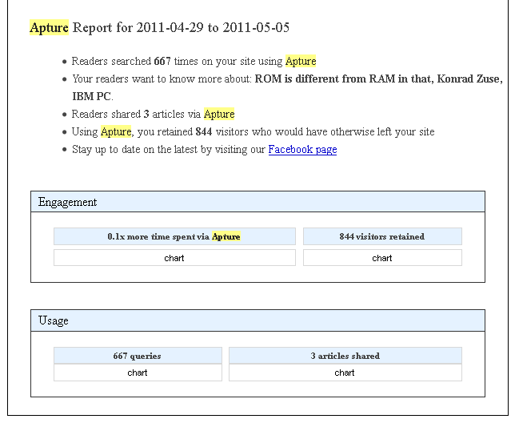
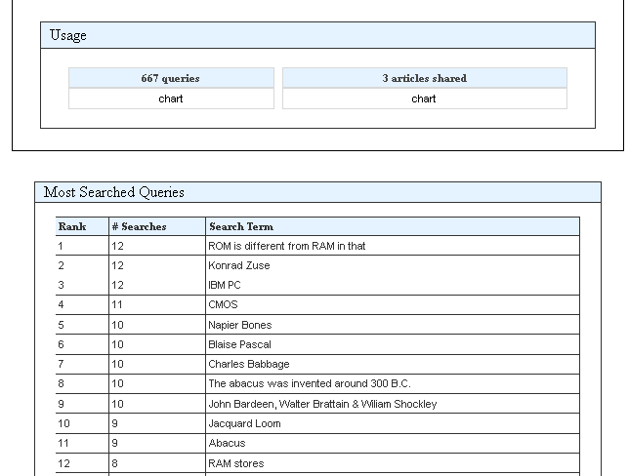

Appendix II – Sample Student Logbook (Stamford College Malacca)

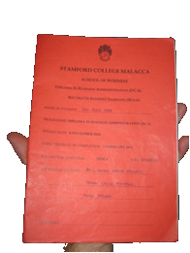

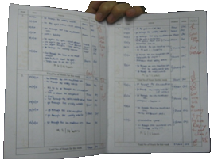

Images show the outside cover of a DCA Student Logbook and the inside writings

Appendix III – Questionnaire

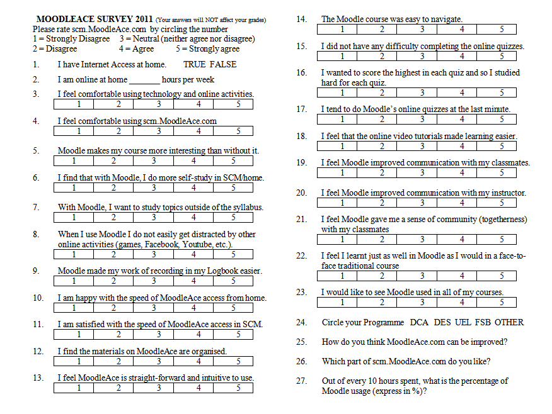
.

THANK YOU

For further information on this MSc. Thesis, please contact me:
Frankie Kam
boonsengkam@gmail.com
012-6585109
Stamford College Malacca
(9 May 2011)

